My tutorial today will take you through the steps of creating the binding for my book. While it may seem complicated at first, it is actually a quick and easy process once you have gone through the steps a few times. Refer to the accompanying pictures for clarification if you find any step confusing.

1. Choose a piece of fabric (or decorative paper) as your book cover. I chose a beautiful piece of Japanese indigo shibori. Cut two pieces of book board to equal sizes that will become the front and back covers of your book. Mine measure 2.75 x 3.5 inches.

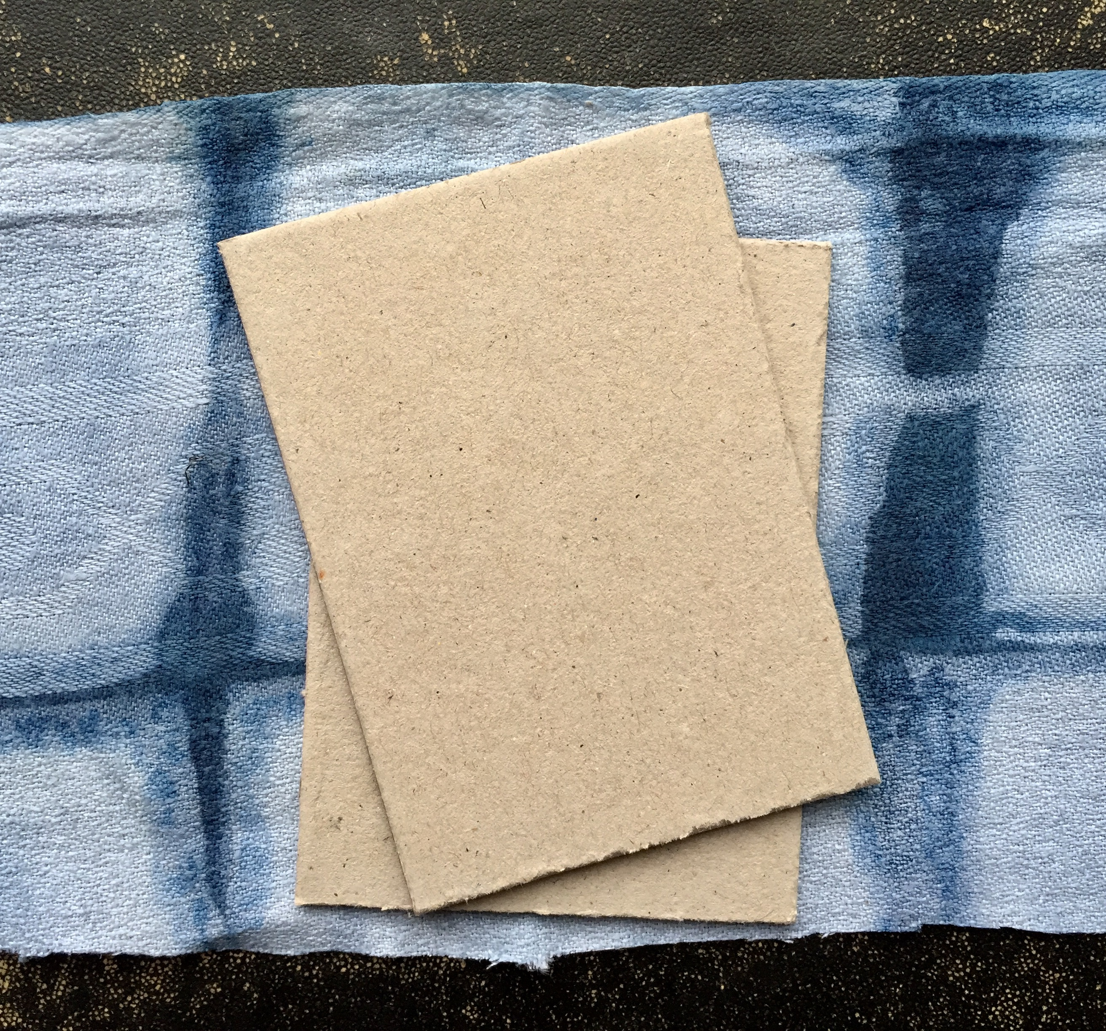

2. Trim your fabric so that it extends approximately .75 inch from each side of the book board. For me, the fabric measured 4.25 x 5 inches. Do this twice for both covers.

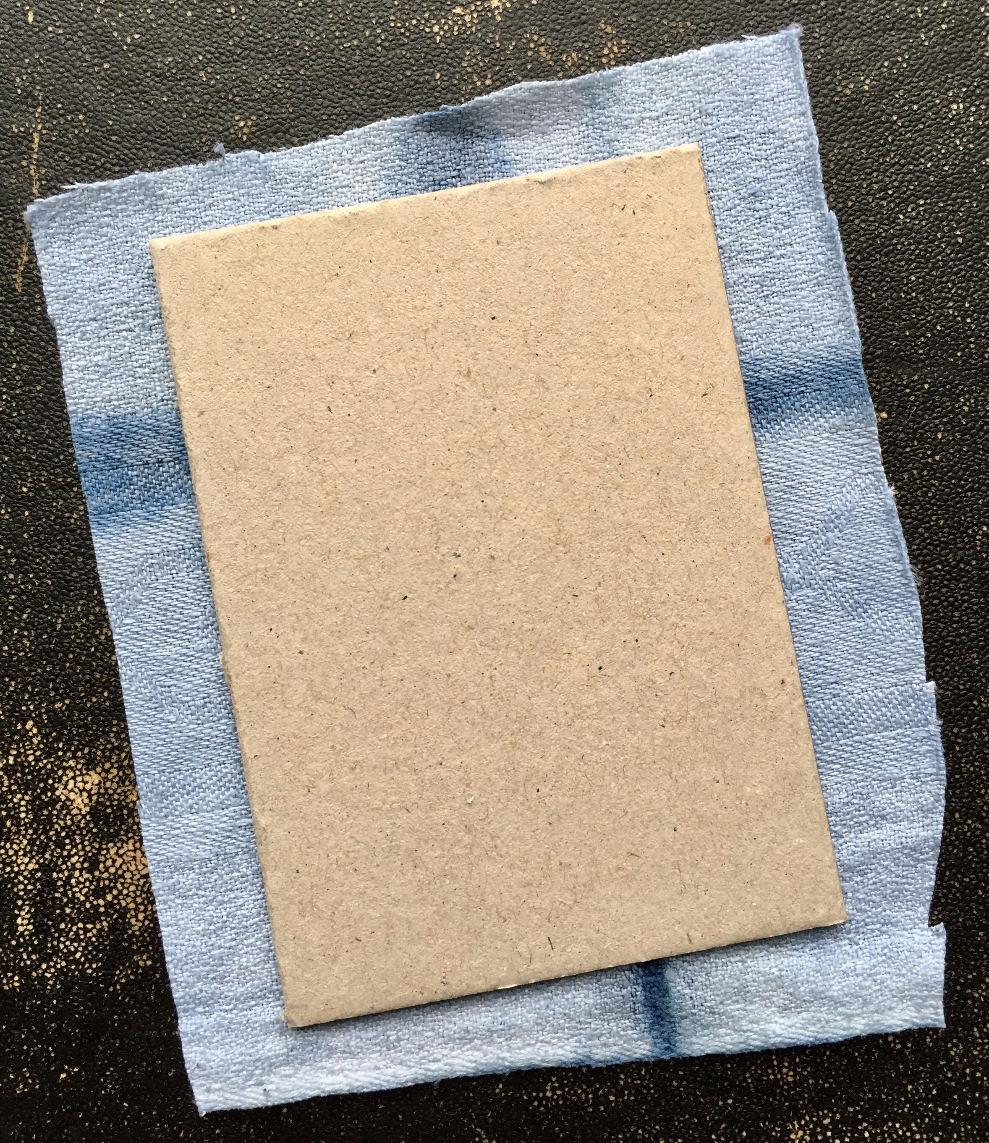

3. Snip off/miter the corners of each fabric piece, making make sure that the fabric still extends just a bit from the corners of the book board (as can be seen in the picture). Do this twice for both covers.

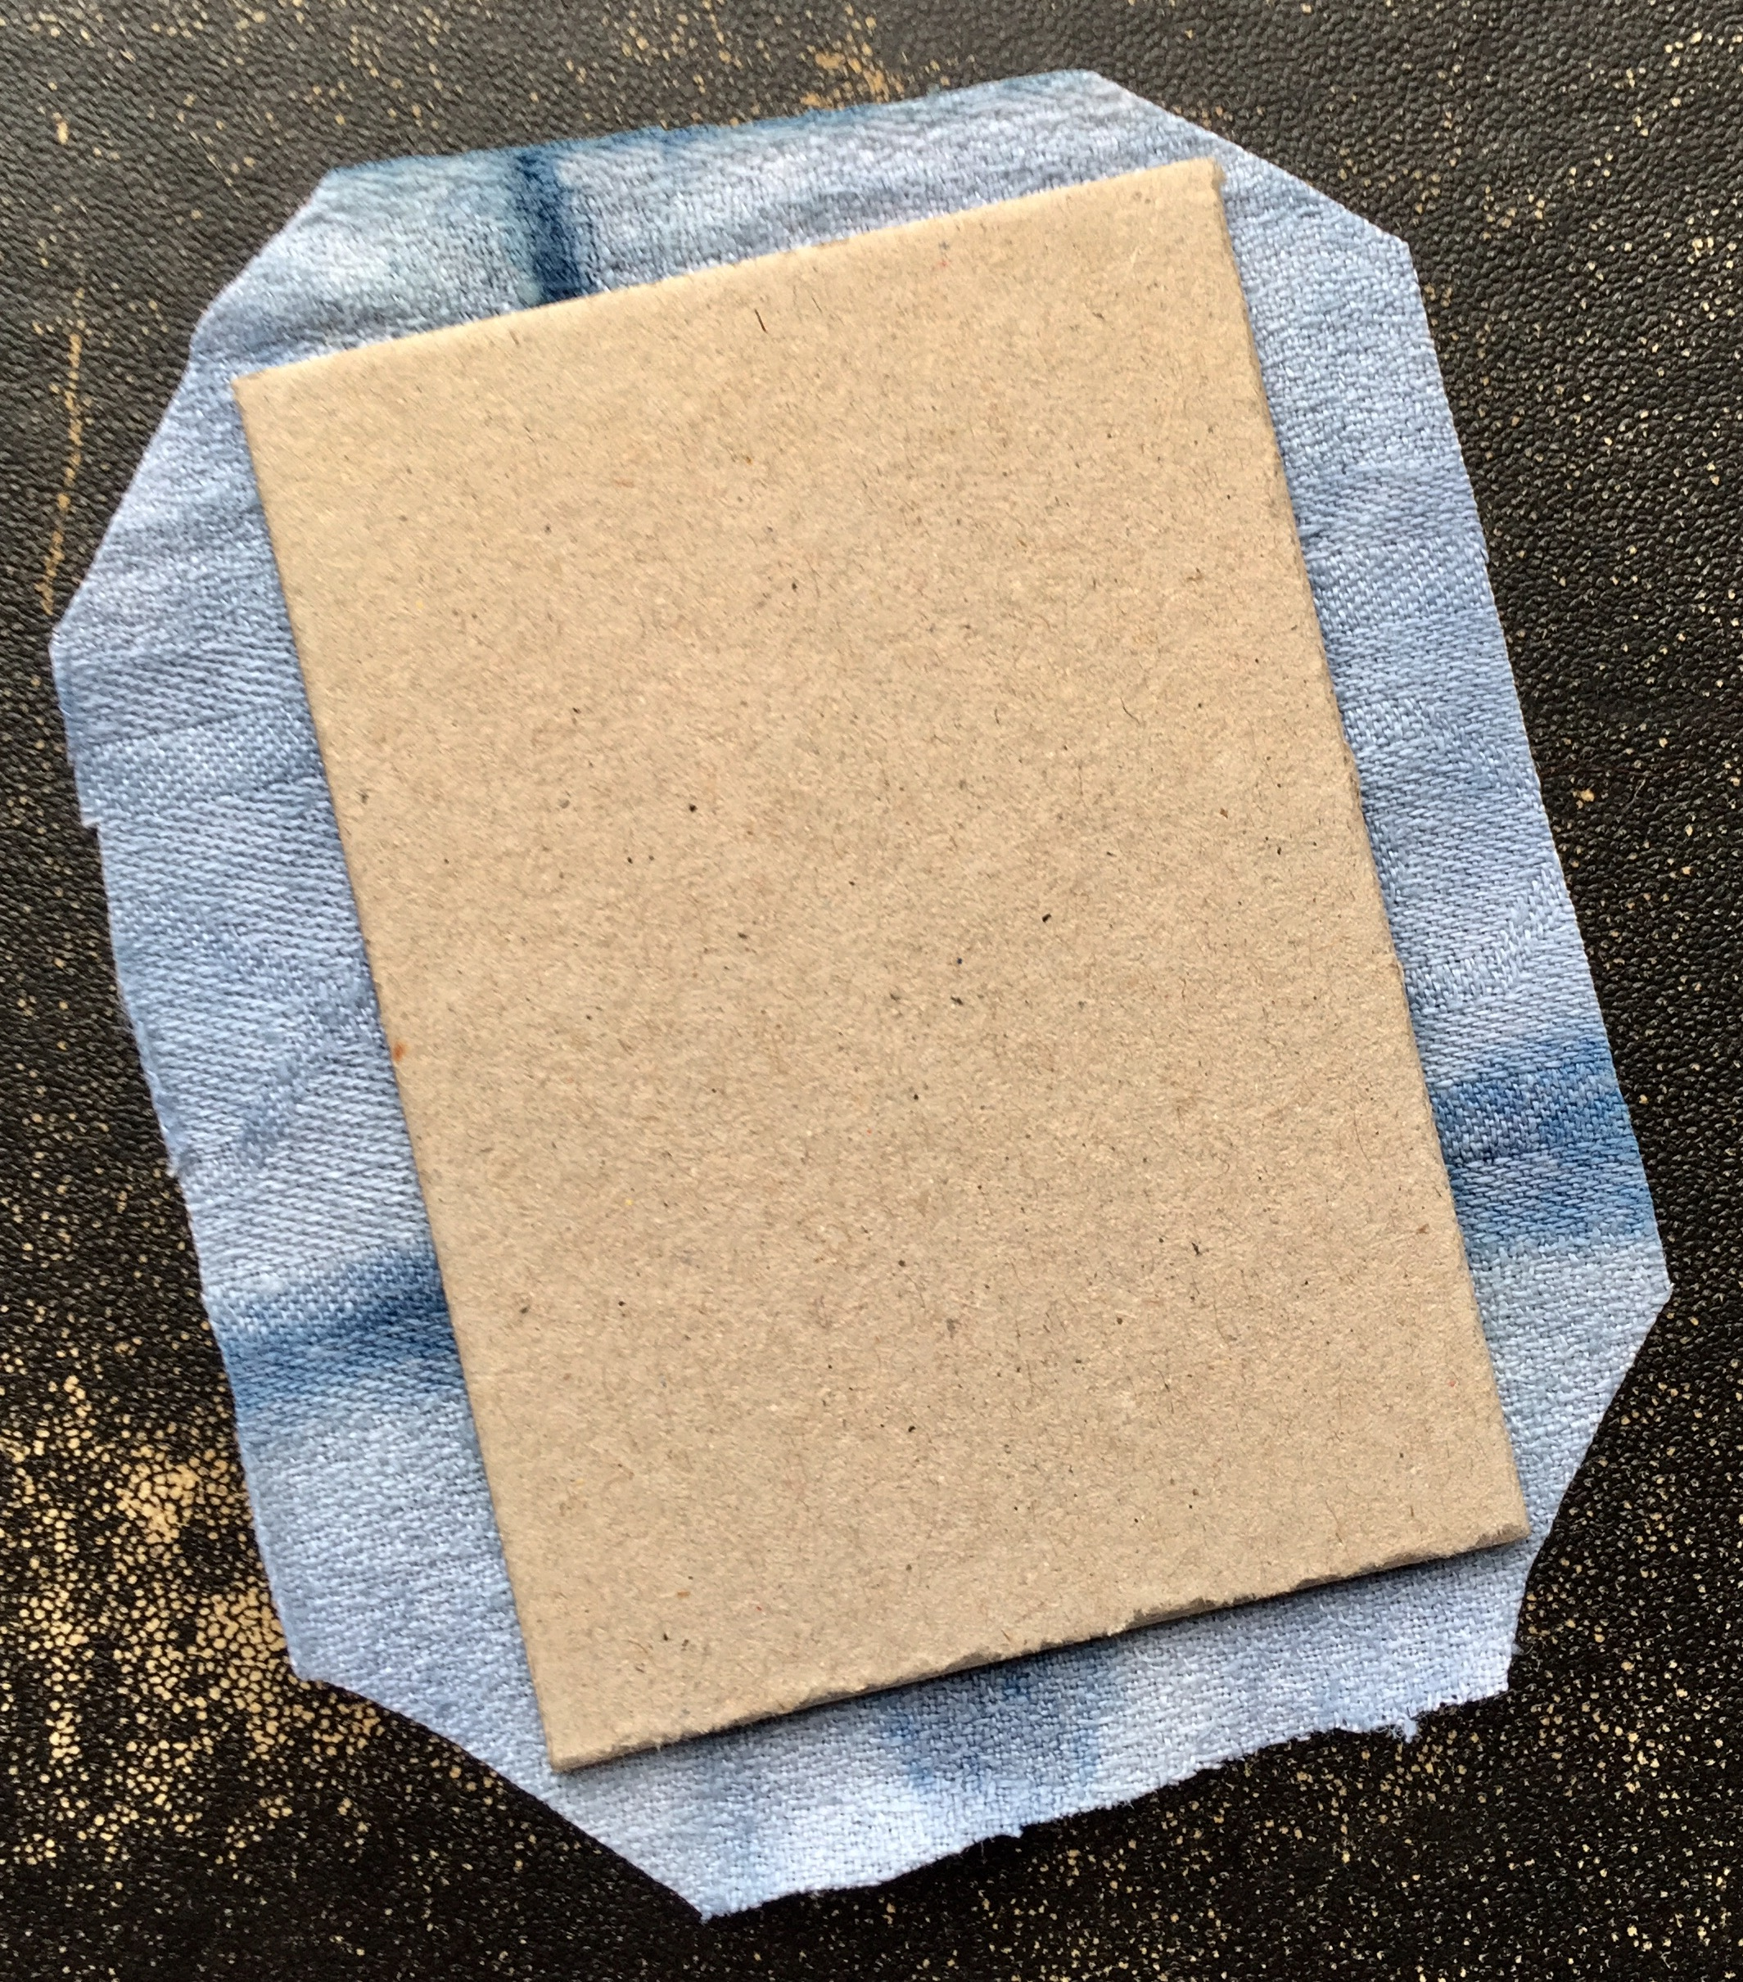

4. Add glue to one side (we will call this the front side) of one piece of book board and place, glue side down, in the center of one piece of fabric. One side at a time, add glue to the part of the fabric that extends from the book board, turn it, and adhere it to the backside of the board. Repeat this process until all four sides are glued and do the same with the second piece of book board. The corner mitering you did in step 3 will allow the fabric at the corners to lie flat.

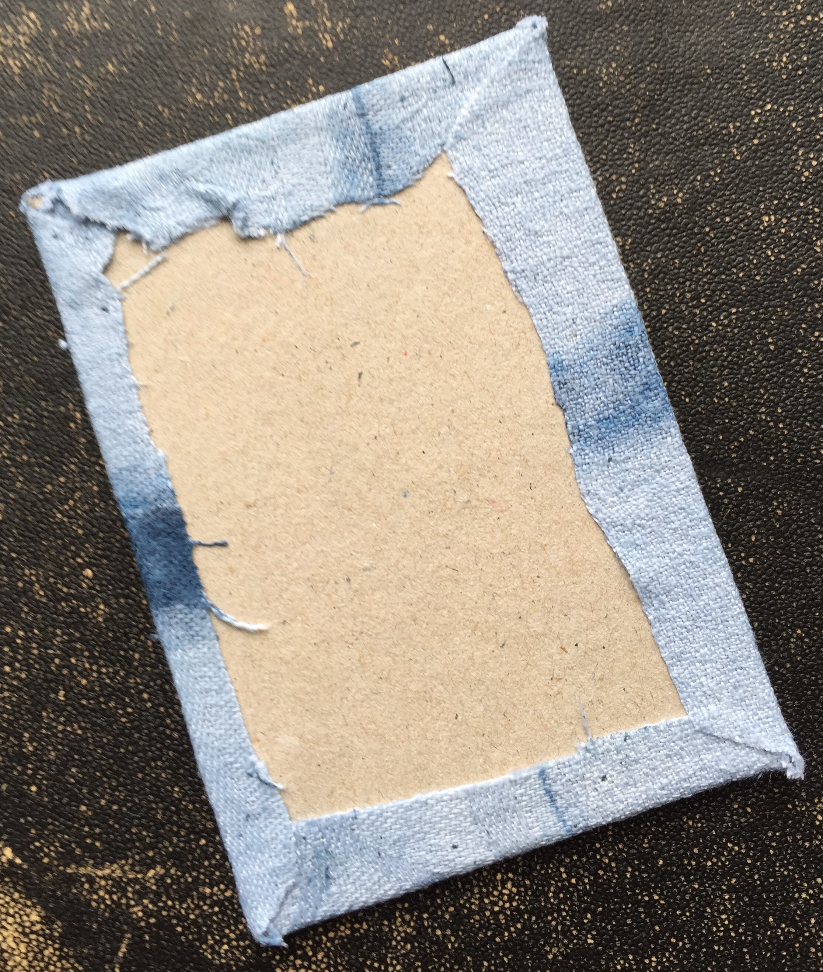
5. We now move onto creating a binding bar for the book. Cut strips out of card stock with a width of 1 inch and a length slightly shorter than the length of your book covers. So for example, my book covers measured 3.5 inches long and my card stock strips measured 3.25 inches. Cut 1 more strip than the number of pages you want in your book.

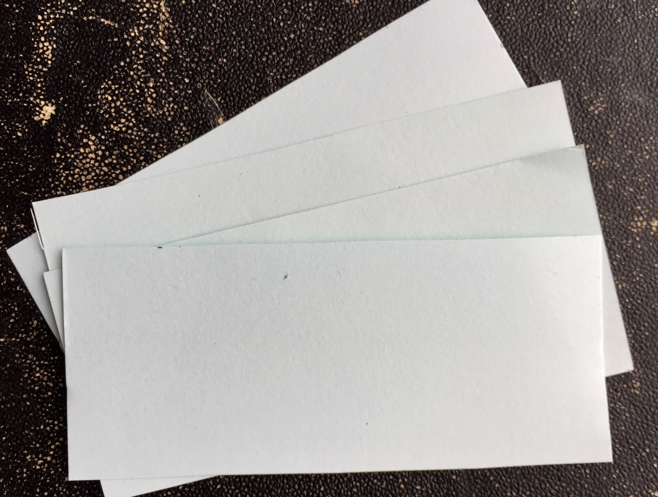
6. Fold the strips in half lengthwise.

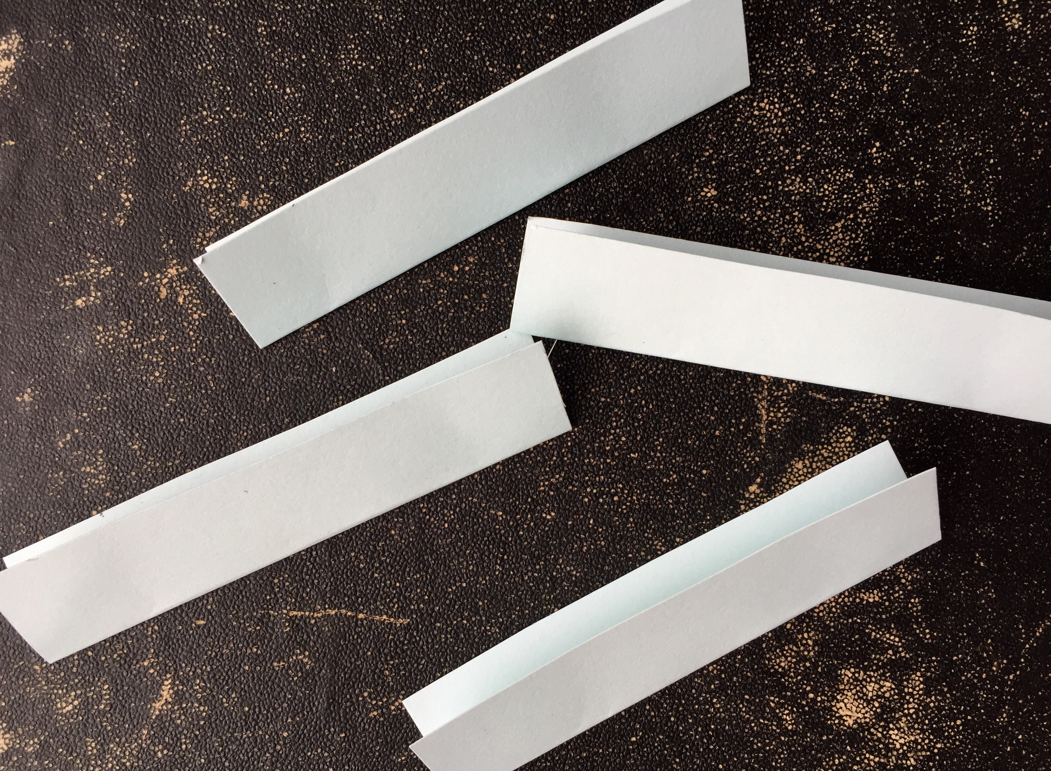
7. Glue the strips together so that the folded sides are always lined up. When complete, allow to dry. This will be your binding bar.

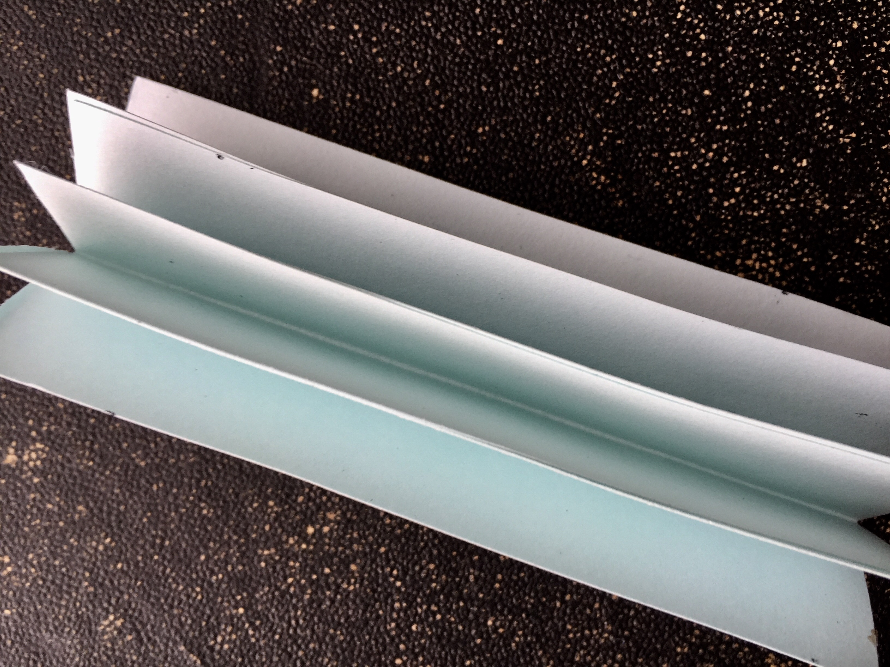

8. There will be a single loose flap at each side of the binding bar. These will get attached to the covers. Line up the folded edge of the binding bar to the inside left edge of your cover. Add glue to the loose flap and adhere the binding bar to the cover. Allow to dry.
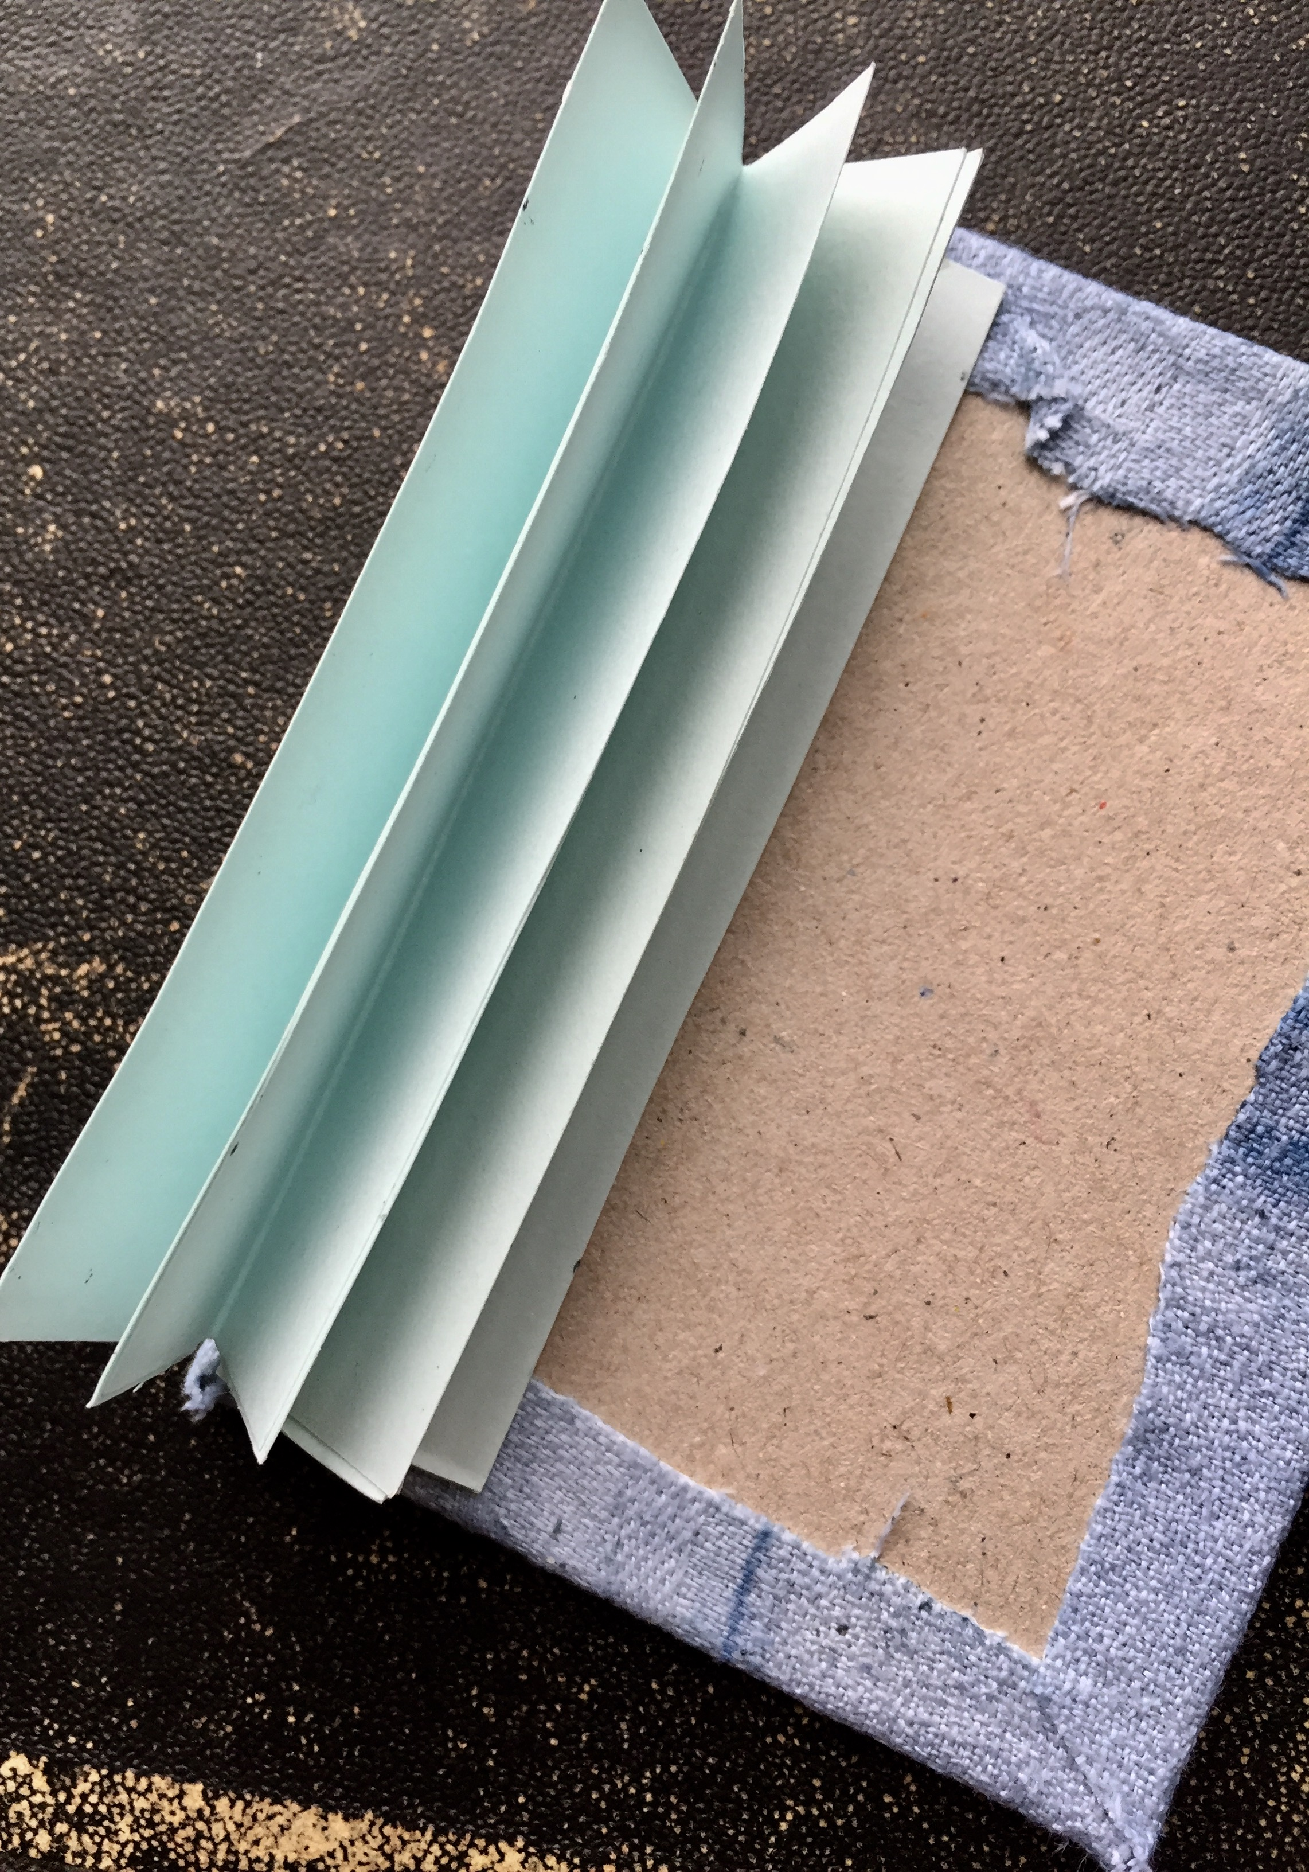

9. Using an awl, puncture two holes into the binding bar strip that is glued to the cover. The holes should be about half way across the width of the strip and about .75 inches from both the top and bottom edge of the book cover. See the placement in the photo for clarity.

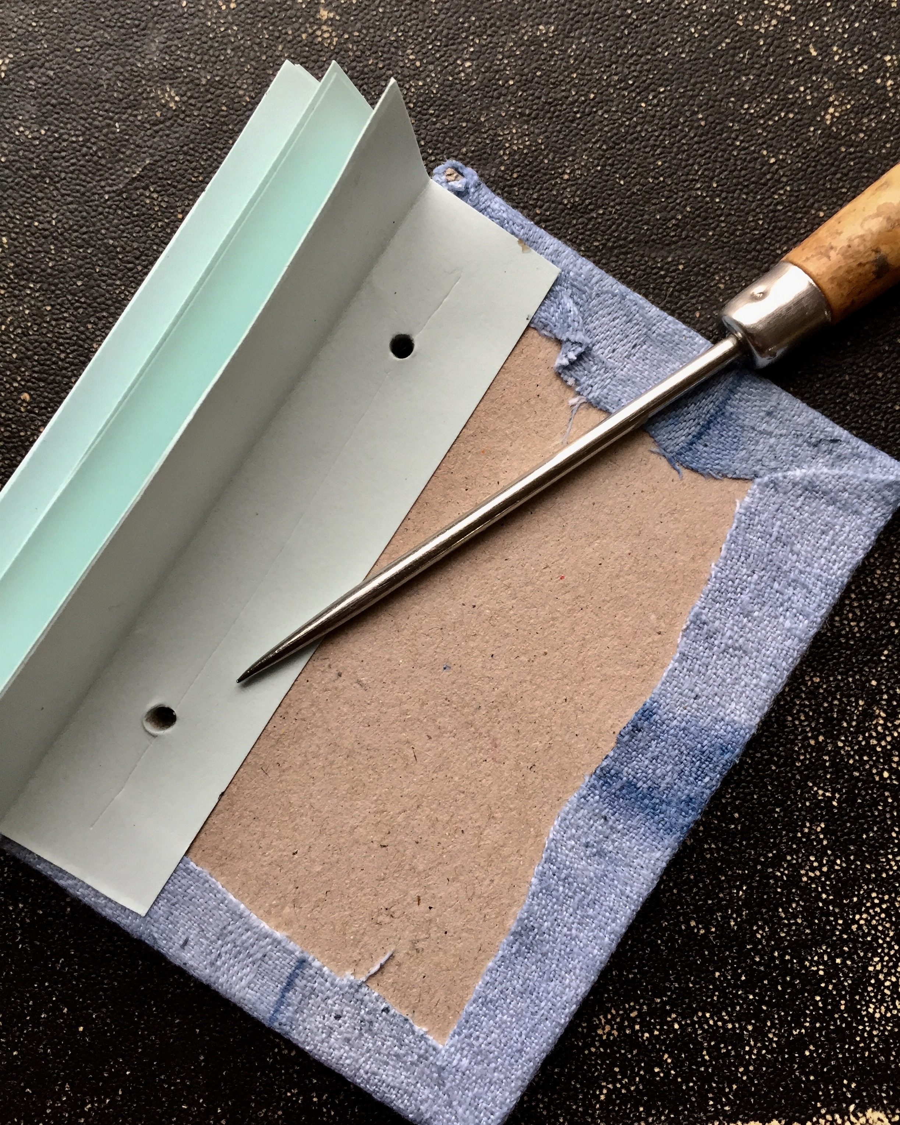
10. Insert a brad through these holes so that the prongs of each brad fold down on the inside. These will function as decoration as well as functional elements to secure the binding bar to the book cover.

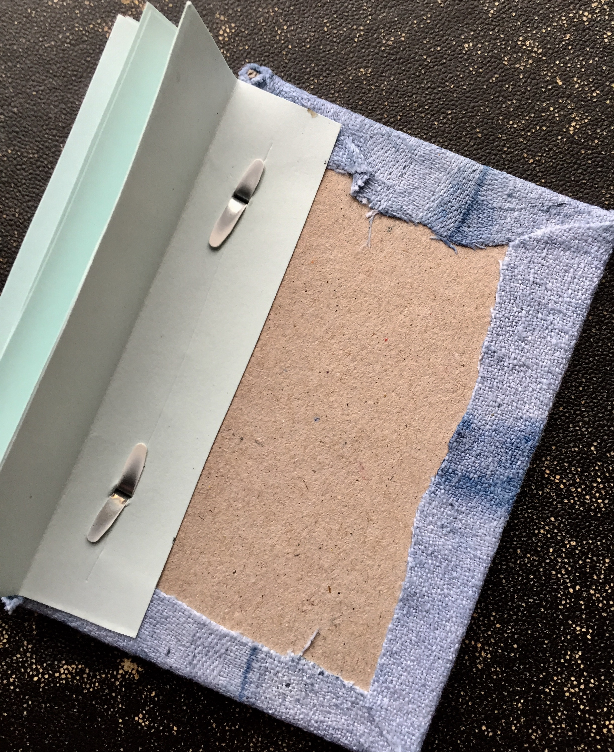
11. Repeating the instruction in step 9, glue the back cover to the loose strip at the other side of the binding bar. Make sure the fabric-covered side of the back cover faces out and that the two book covers are aligned.

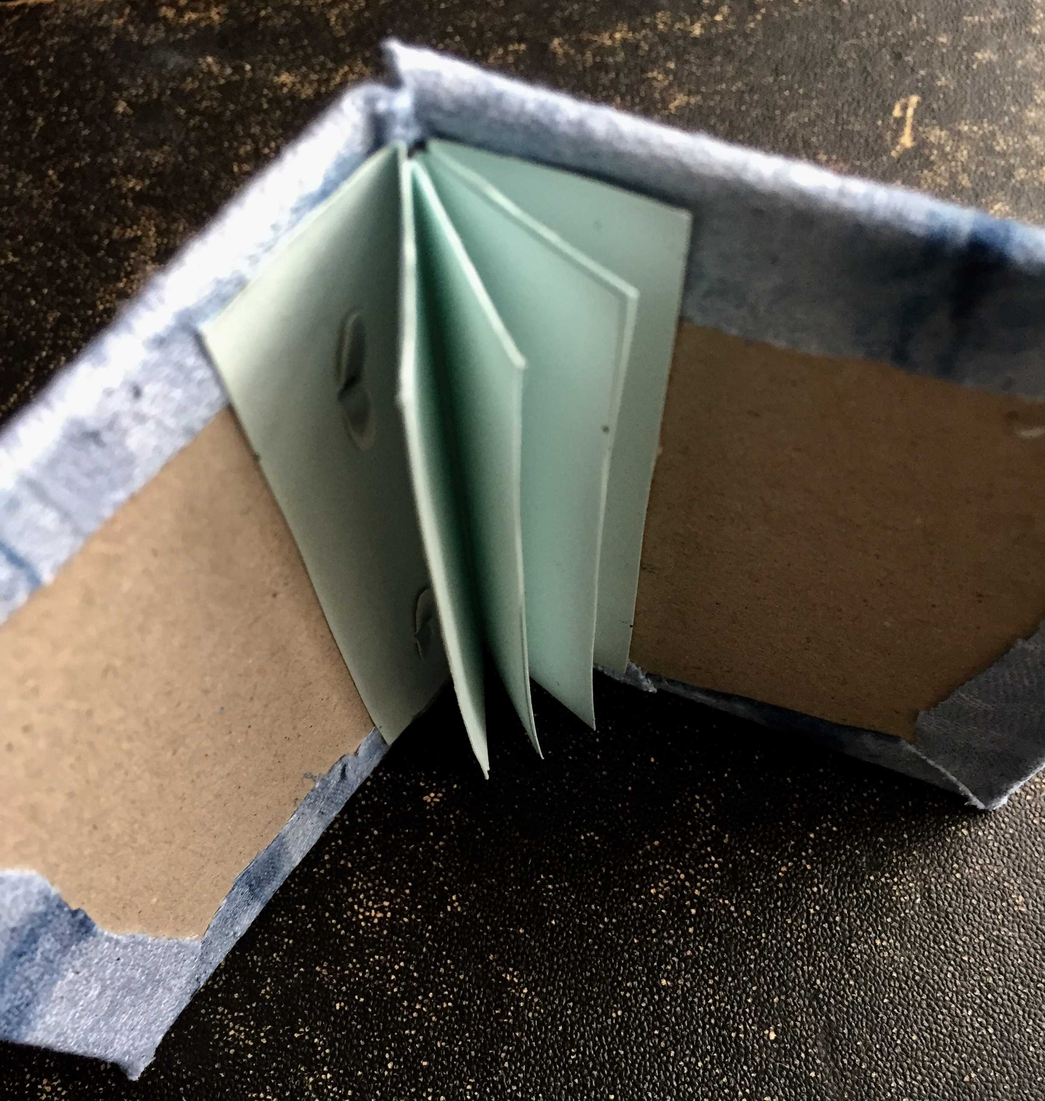
12. Cut two pieces of decorative paper slightly smaller then the book board covers. Adhere one to the backside of the front cover and the other to the backside of the back cover. This will service to cover the fabric edges and brad prongs and give your book a finished look.

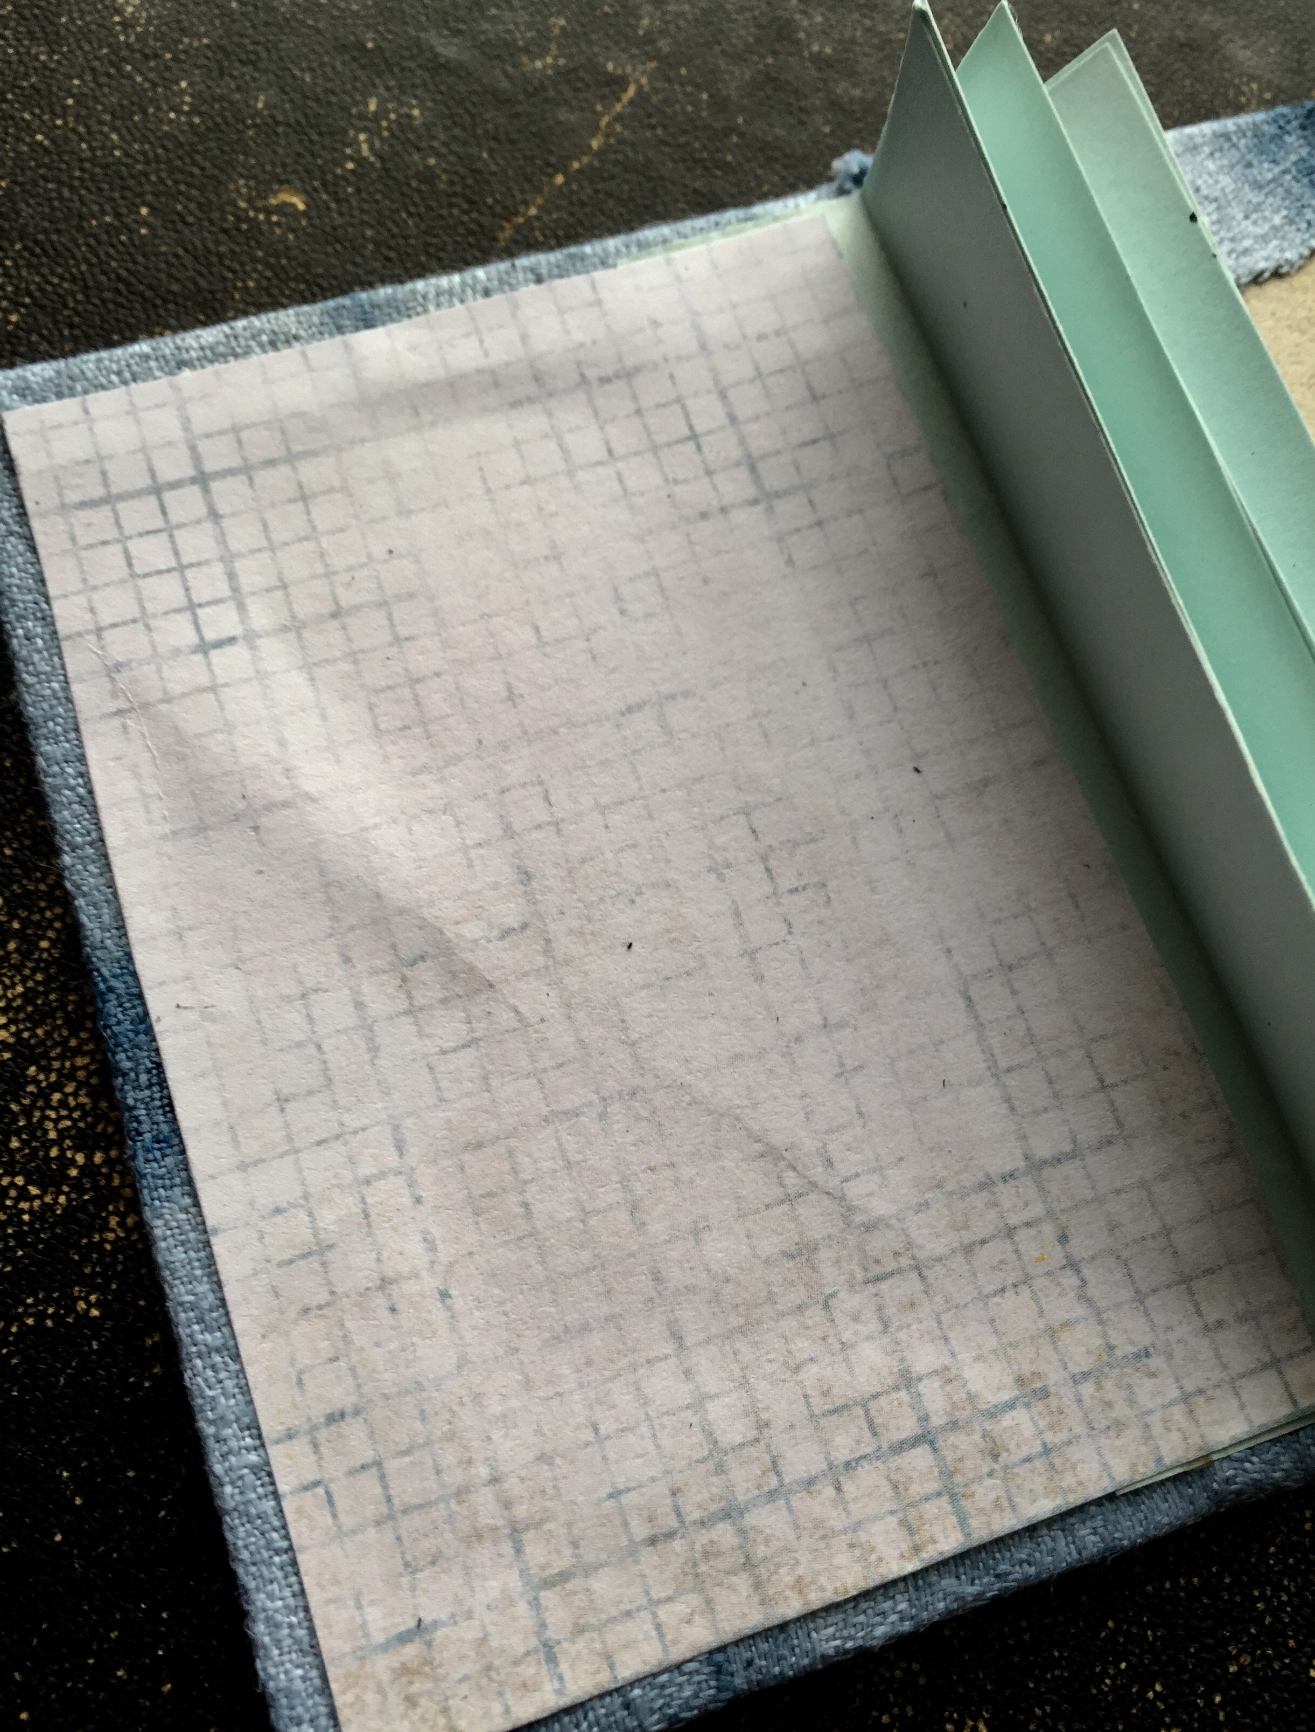
13. You can now glue pages to the flaps inside the book, one book page per flap. Adding more than that will make your book splay open. Use can use paper, fabric, ephemera, photographs, etc. as the base of your book page. I chose to collage on each page using vintage Japanese ephemera and further decorate with ink, stamps, and bits of fabric.

