"Fate Loves the Fearless" Tag
by Sharon Laakkonen

Quote: Being fearless is really the most basic tenet of freedom that one can experience. Fearless to try new things, go where one has never gone before, listen to those you disagree with, learn from it all. That is what epitomizes the Americas to me...the freedom to be different, to be diverse in cultures, foods, language, thoughts, skin colors, customs, music, clothing, and so much more. To take all of the Americas and wrap them up in one little project seemed difficult to do! Where does one start? I took a few memories of my visits to South America and blended them with my experiences of living and traveling in North America.

Material List:
Prima's Zella Teal papers, stickers, crystals, washi-tape, chipboard tag. Finnabair canvas, glossy gel, and silver micro-beads. Other: seam binding, cheesecloth.
Text:
Each product on my tag represents a part of the greatness of the Americas through my eyes, while also including a touch of darkness as all of the Americas have their own mix of good and bad times throughout history. My hope is that the light, the goodness, will eventually overcome the darkness in all of our hearts.
The tag's base colors are cool and tranquil, with splashes of turquoise thrown in, droplets of silver, a torrent of white, woven fabric, sparkling gemstones, an arrow, feathers, and the crowning touch...a bird in flight. Each one represents a symbol, a landmark, a part of the amazing Americas.

Instructions:
1. Cover chipboard tag with paper. Add washi tape to bottom. Collect canvas, cheesecloth, and 3"x4" quote card.
2. Adhere piece of canvas or fabric + cheesecloth with a touch of fabric glue.

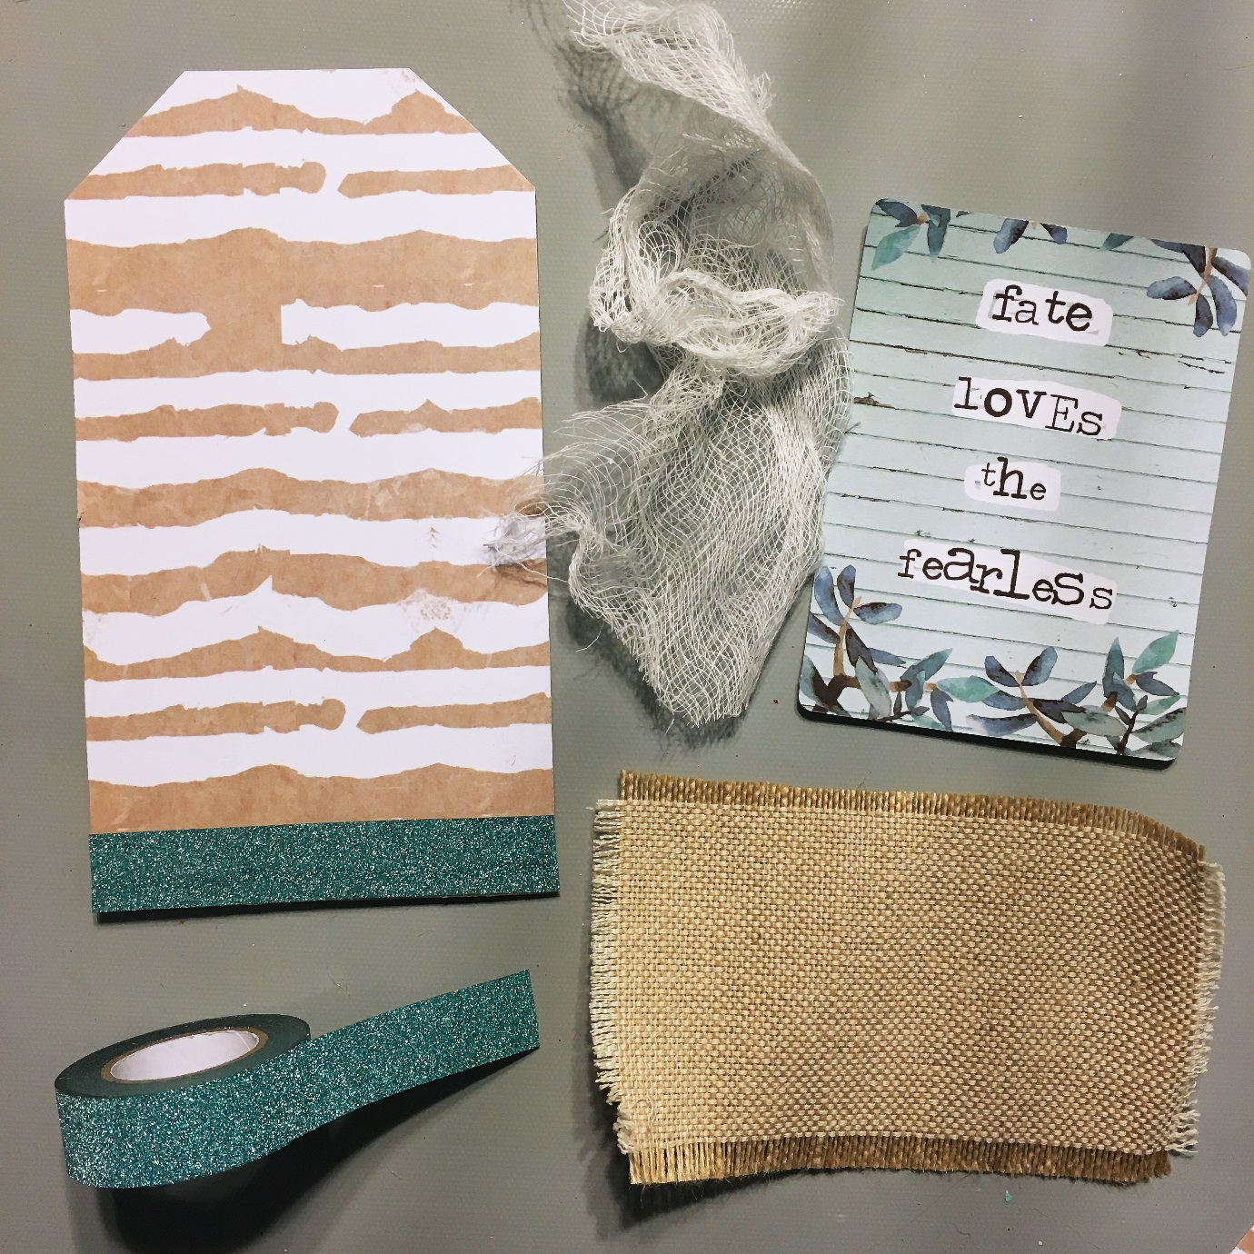
3. Layer 3"x4" quote tags and add a piece of cardboard or foam squares to back. Adhere to tag as shown.
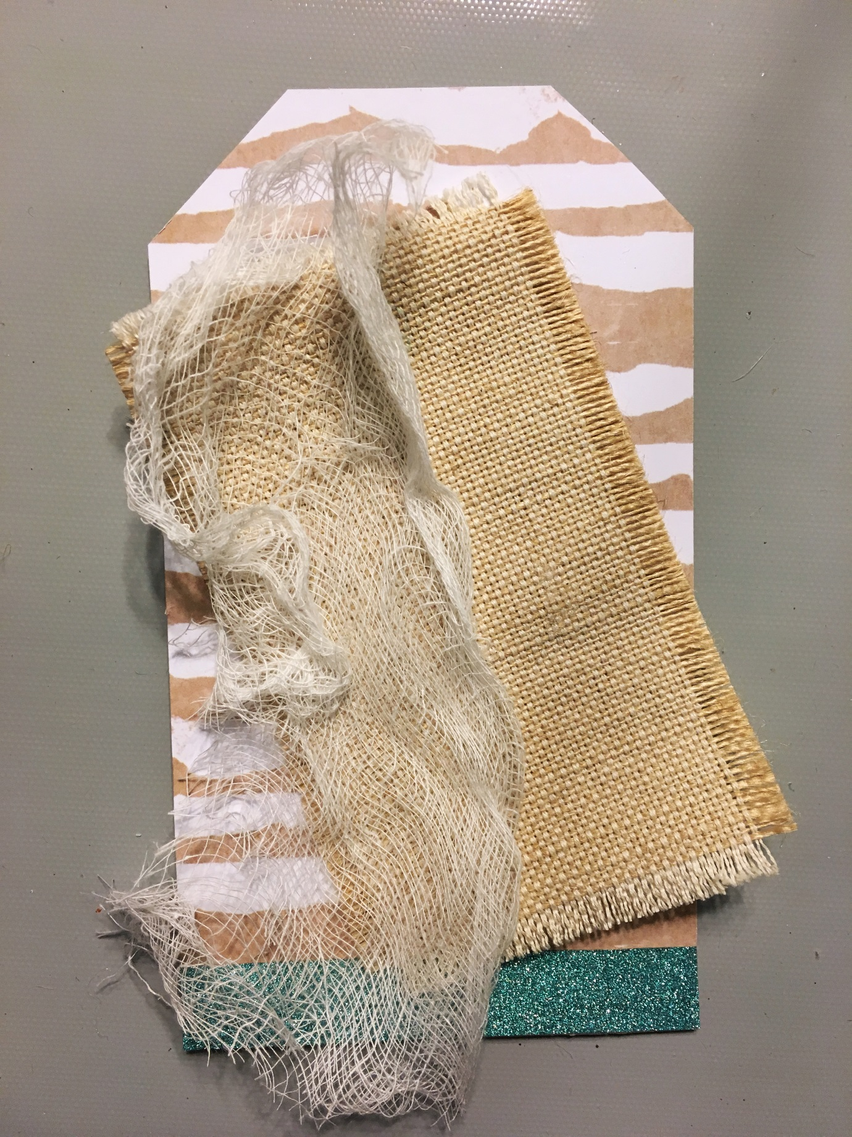
4. Add feathers: tuck a silver foiled feather slightly under quote card on left side. Add two feather stickers on left side of quote card.
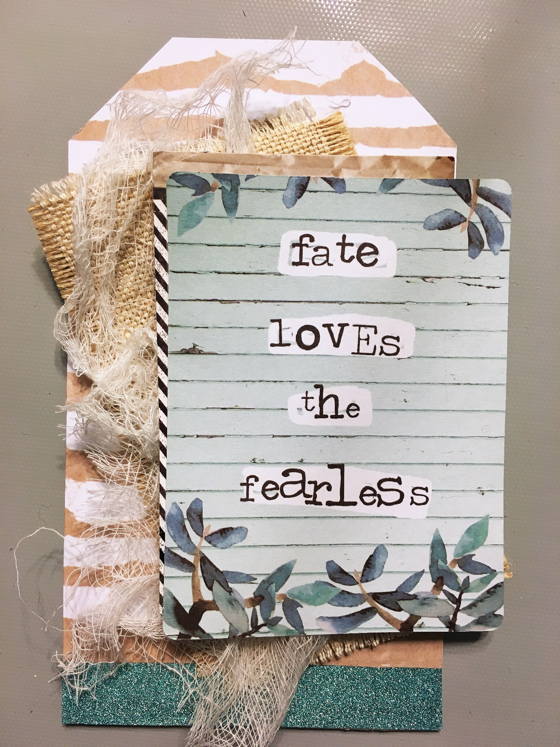
5. Add bird with foam tape or squares to top left of quote card. Add circle tag under left corner of quote card.​
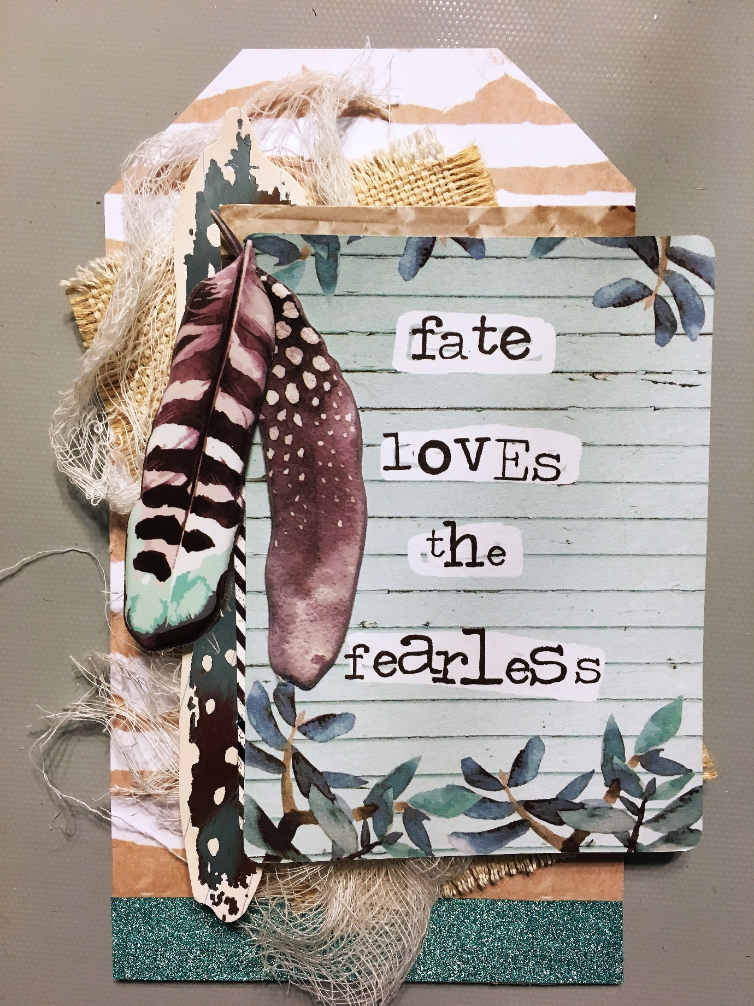
6. Apply soft gel to tag where desired. Quickly sprinkle silver micro-beads on top.
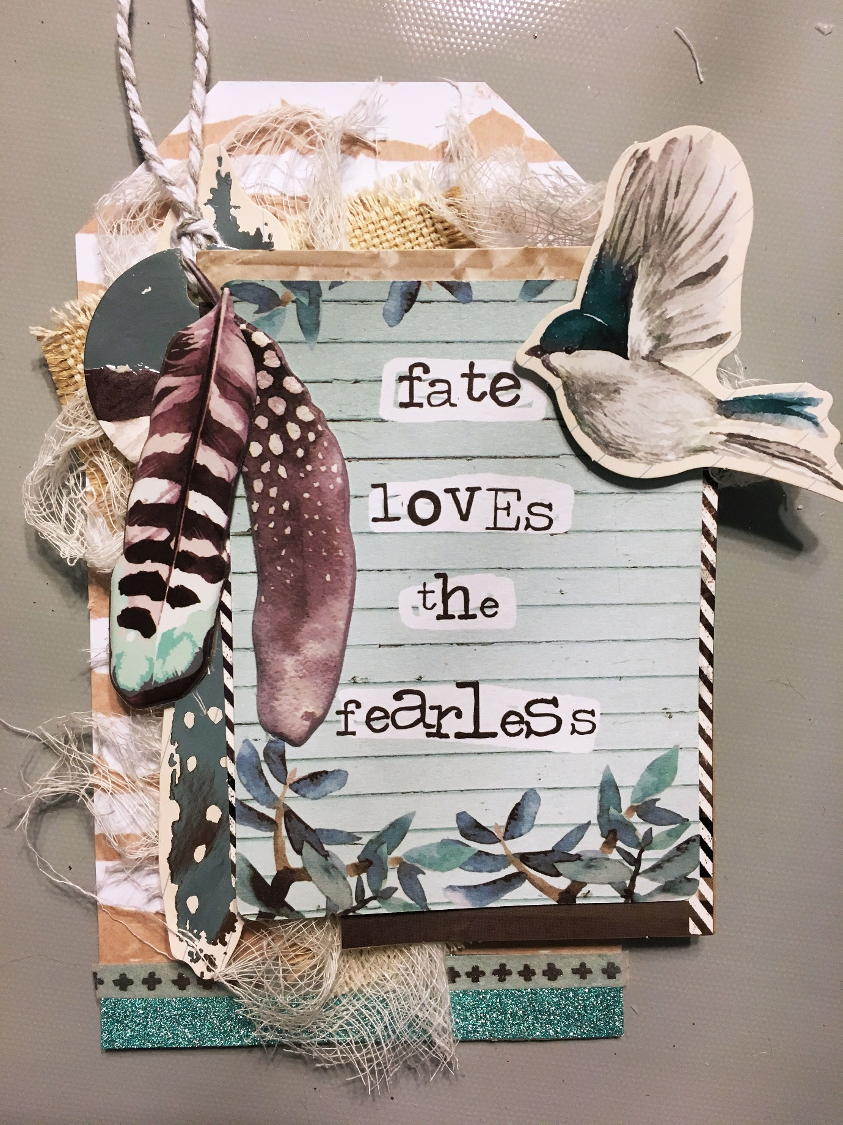
Step 7 - Add crystal gems as desired over tag. Tie ribbon to top.
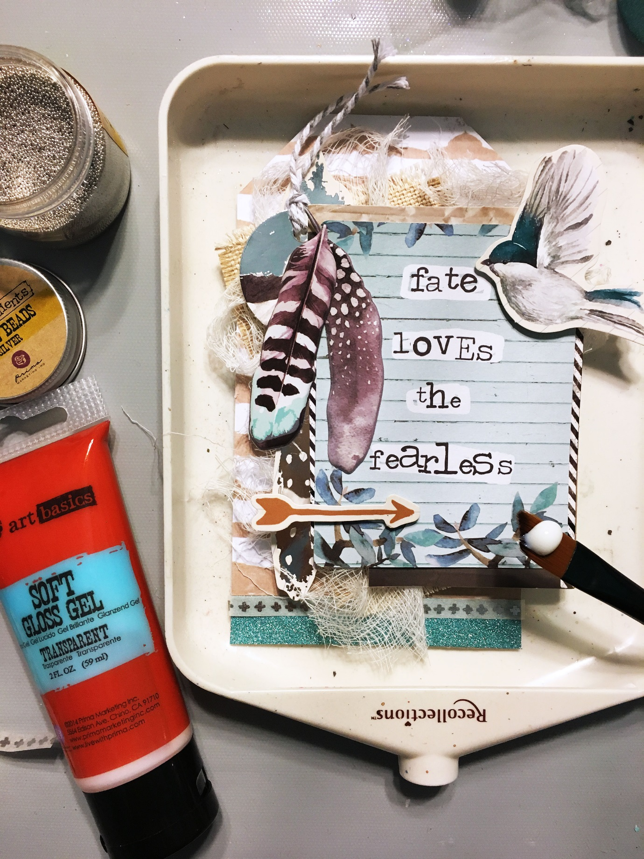
Tips:
1. I love using cardboard instead of foam squares. It's inexpensive and everyone has some to reuse!
2. Fabric glue will work with every medium. Fabri-Tac is my favorite.
3. Save all of your paper scraps and use them here and there on tags. I often keep my extras in a large glass jar and rummage through it when making tags,

