AALL & Create International Tournament 2017

Project Title: Canvas Painting – The Three Sisters
Material List:
- Canvas - Mont Marte
- Acrylic paint - Mont Marte

By: Louise Nelson

Quote: For my project I have painted a canvas of three sisters – the story tellers, and created a little descriptive story about who they are, to go with it. The painting and the story are not based on truth or any actual Aboriginal ‘Dreamtime’ stories, however they were the source of inspiration. With the title ‘The Art of Story Telling’, and taking inspiration from the Countries, Cultures and Art forms from the countries making up Australasia It felt right to use my own home country Australian Indigenous Aboriginal Art Expressions and Dreamtime stories as a source of inspiration.

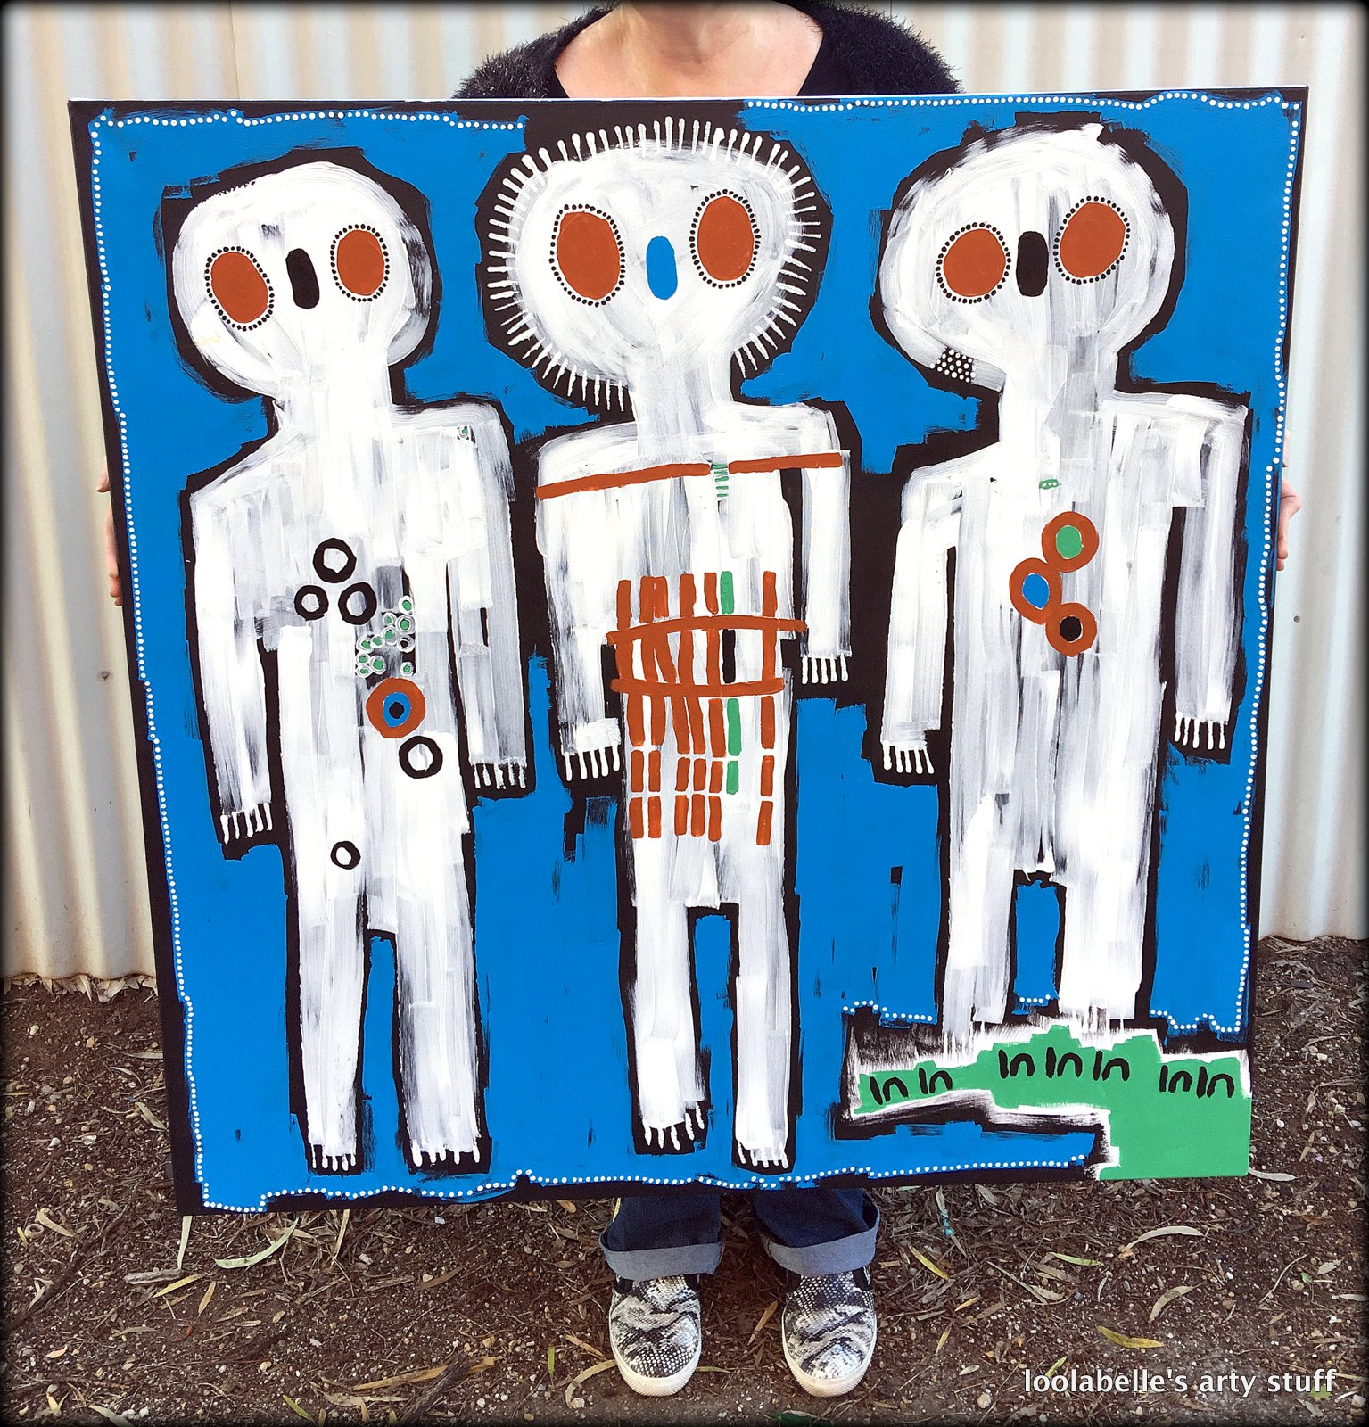

Australian Indigenous Art is the oldest on going tradition of art in the world; estimates date this between 50,000 and 65,000 years. Initial forms of artistic Aboriginal expression were rock carvings, body painting and ground designs.

The quality and variety of modern Australian indigenous art produced today reflects the richness and diversity of indigenous culture and the distinct differences in tribes, languages, dialects and geographic landscapes.

Art has always been an important part of Aboriginal life, connecting past and present, the people and the land and the supernatural and reality.

The ‘Dreaming’ or ‘Tjukurrpa’ means to ‘see and understand the law’, Dreaming Stories pass on important knowledge, cultural value and belief systems to later generations.
Through song, dance, painting and story telling which express dreaming stories, Aborigines have maintained a link with the Dreaming from ancient times to today, creating a rich cultural heritage.

Whilst it may seem like a huge leap! And a big stretch of the imagination. I would like you to think about the similarities between the importance of Art in Aboriginal life and Dreamtime [as briefly described above] to that of the underlying motivation and process of Memory Keeping of Scrapbooking and other art/craft forms that we practice; for example Project life, and Art Journaling. The Art of Story Telling!

Text: The Three Sisters

My canvas is a painting of 3 sisters. I have incorporated symbols and shapes from Aboriginal Art Expressions to decorate the canvas and the actual images of the sisters; dots and dashes, circles, and the symbols for man/woman.

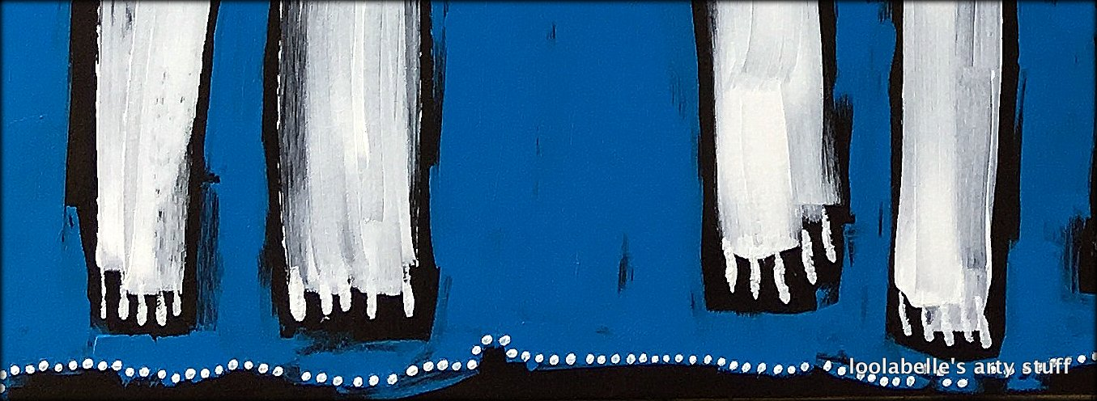
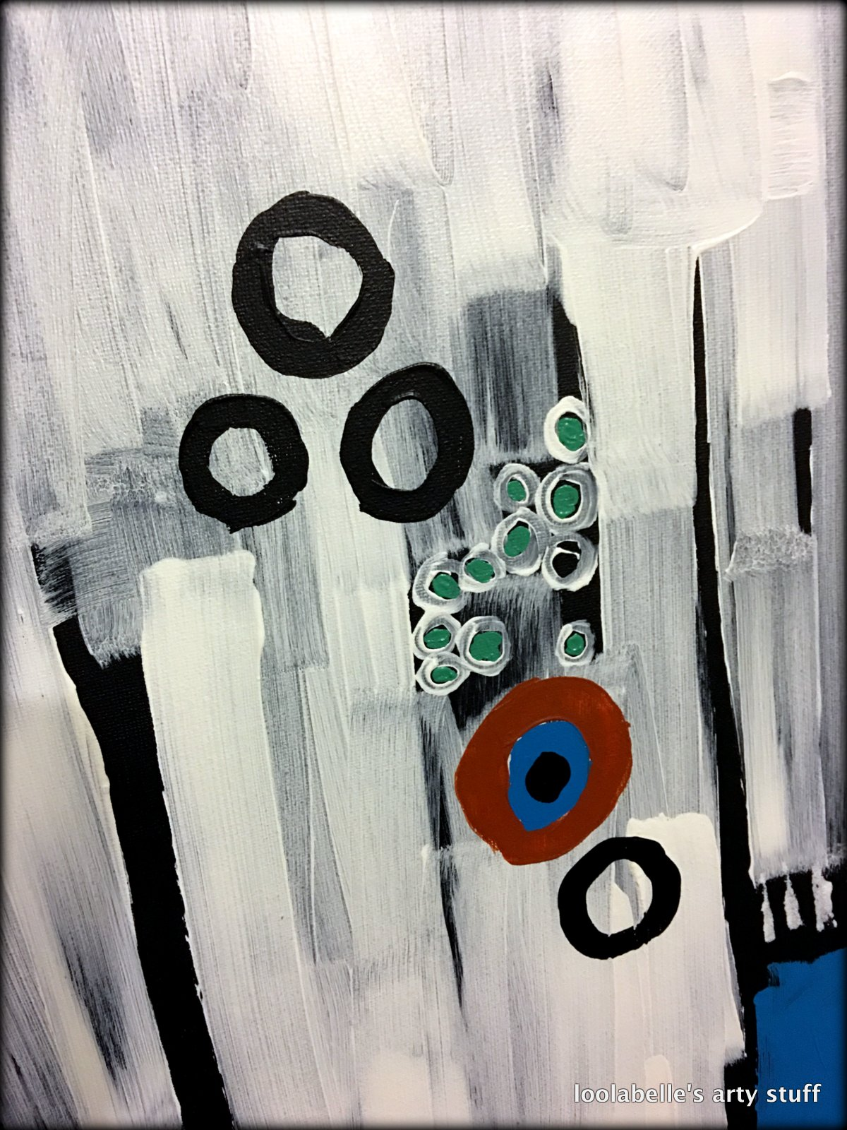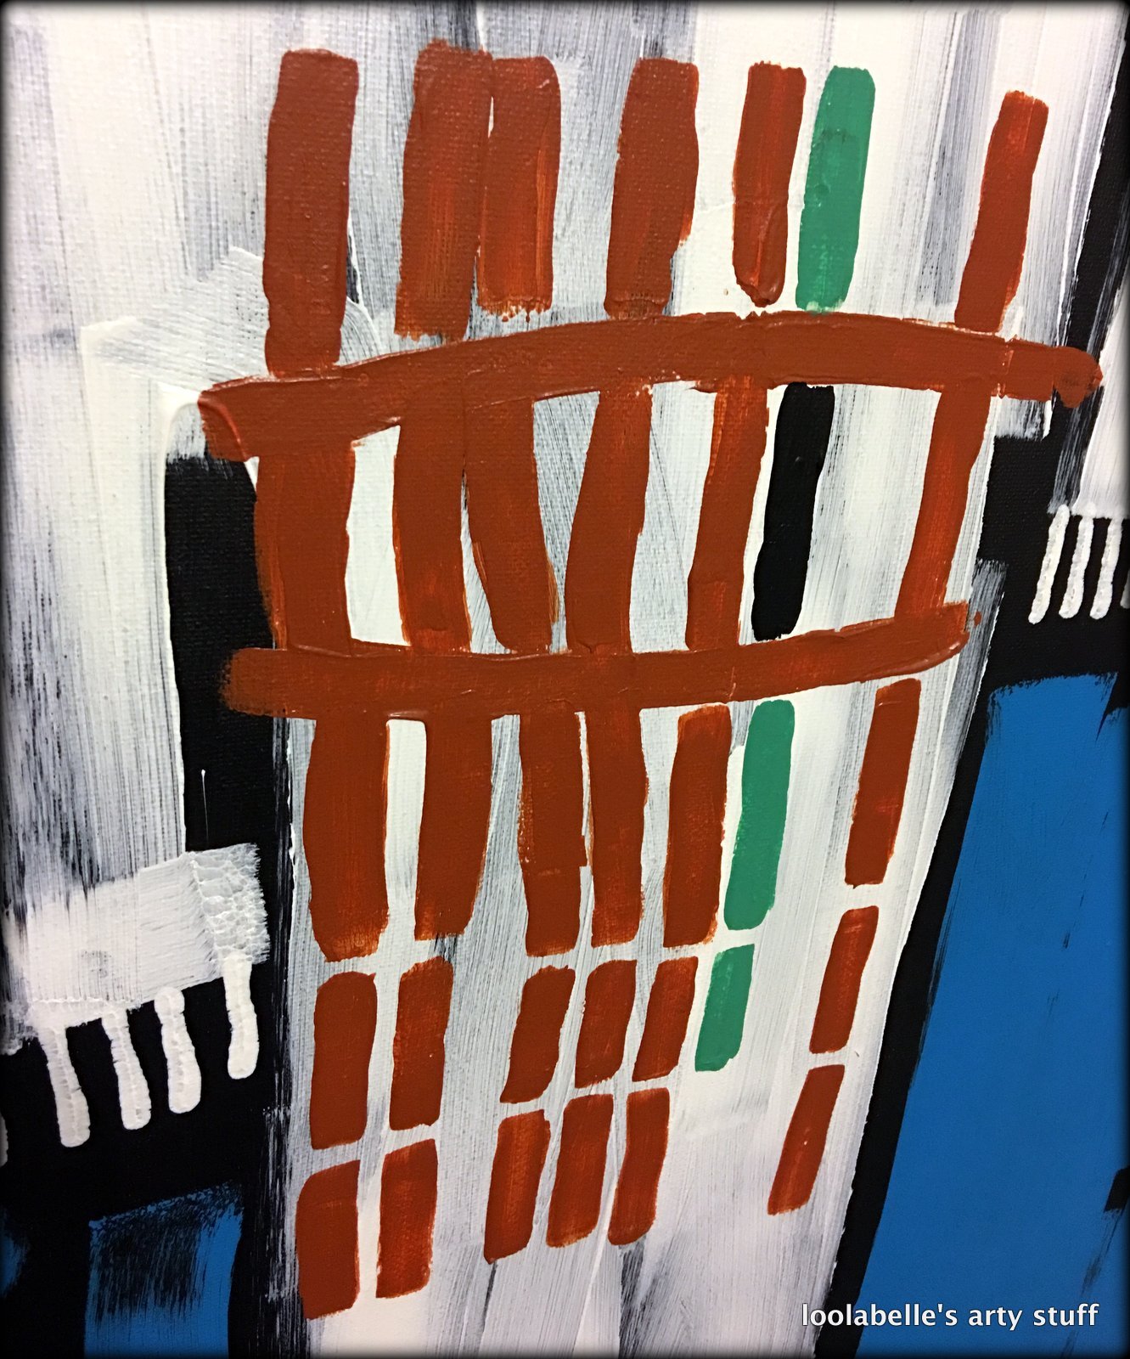

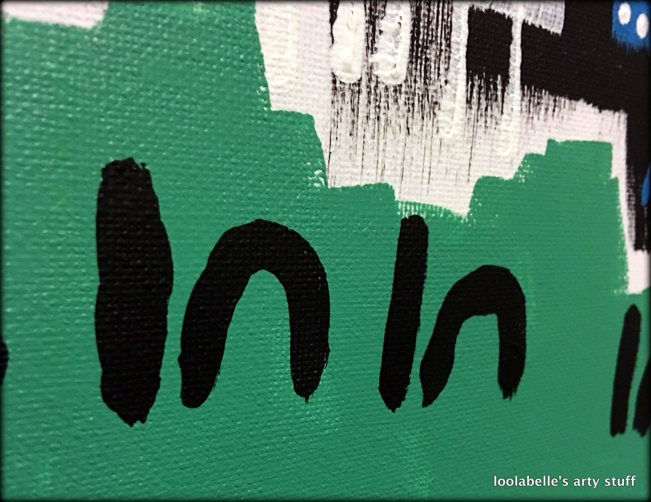

The colour palette for this painting was inspired by the colours of the earth.

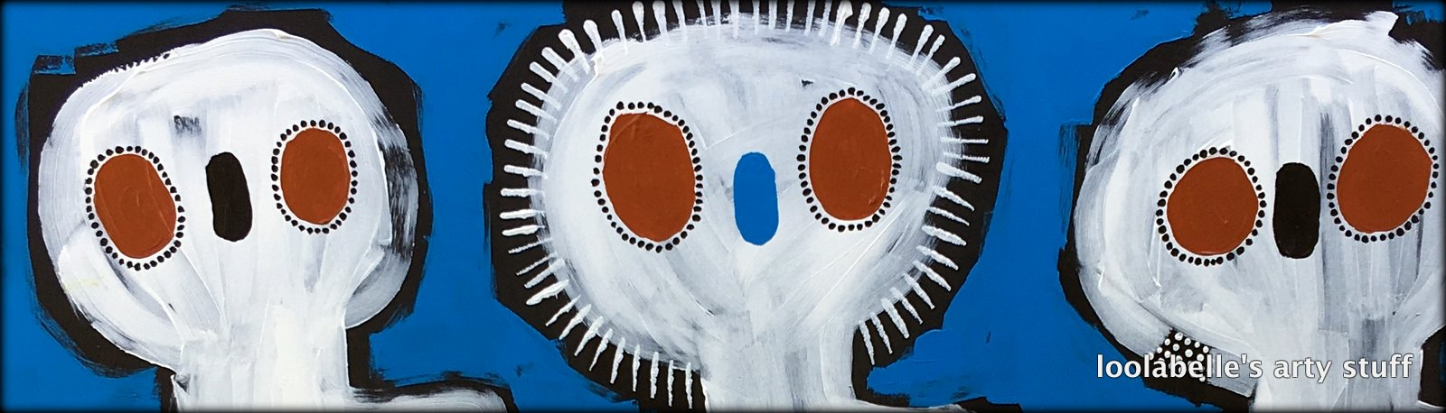

I was also inspired by the traditional Wandjinas body forms; as a way of depicting the sisters. Wandjinas are only found in the artistic expressions of the Kimberly Region of Australia. Traditionally Wandjinas are depicted with out mouths. This was because it was believed that it would make these spirit beings too powerful. So with that in mind, I thought that it would make an intriguing artistic contrast, to depict the story-telling sisters without mouths.

So, I would like for you to think of this canvas depicting the 3 sisters; like an artistic ‘selfie’ photo, and their story is….

The three sisters weren’t actually blood sisters, however they were all members of the same close-knit aboriginal community. They were all well respected older female members of the tribe; so much so that they inherited the sacred task of keeping and passing on the tribal ‘Family History’. The important stories of family life, within the community; births and deaths, milestones and major achievements. They were the living guardians of the family and tribal history, the memory keepers, and the story-tellers; ensuring that the memories were not lost and that they were imparted to the later generations.

Well that is the story of my canvas, I do hope you have enjoyed how I have translated the challenge into a ‘painting selfie’, The three sisters, The story tellers.

The Art of Story Telling.

