35 Feathers

Hi there everyone, today I've brought you a little splash of color to brighten your day, it's a 12" x 18" spread with various, exciting vibrant colored layers, sandwiched between the lush layers are 35 journo stylee feathers, 1 feather for each capital of the Americas. The hot and cool tone colors dance and bounce round the page, the gold paint adds sparkle, foils shine brightly catching your eye and the micro beads and texture paste add the perfect amount of texture in mini doses. The feathers are a pleasure to create and easy peasy...

Ingredients

Stampotique Stamp 'Feather'
Prima Watercolor Confection Paints
Coloring Pencils
Finnabair Art Alchemy Impasto Acrylic Paints
Finnabair Art Alchemy Sparks Acrylic Paints
Finnabair Art Ingredients Texture Powder
Finnabair Art Alchemy Metallique Acrylic Paints
Tim Holtz Mini Stencils
Water-resistant Journal Pens
Watercolor paper
Mechanical pencil or (water-resistant ink for stamping)

Step 1 & 2
Sketch feathers with a pencil or (stamp Stampotique 'Feather' stamp with water-resistant ink) onto smooth watercolor paper and paint the feathers with the watercolor, I used plenty of water with the paints so that the color pooled and bled creating pretty patterns and watermarks when dried.

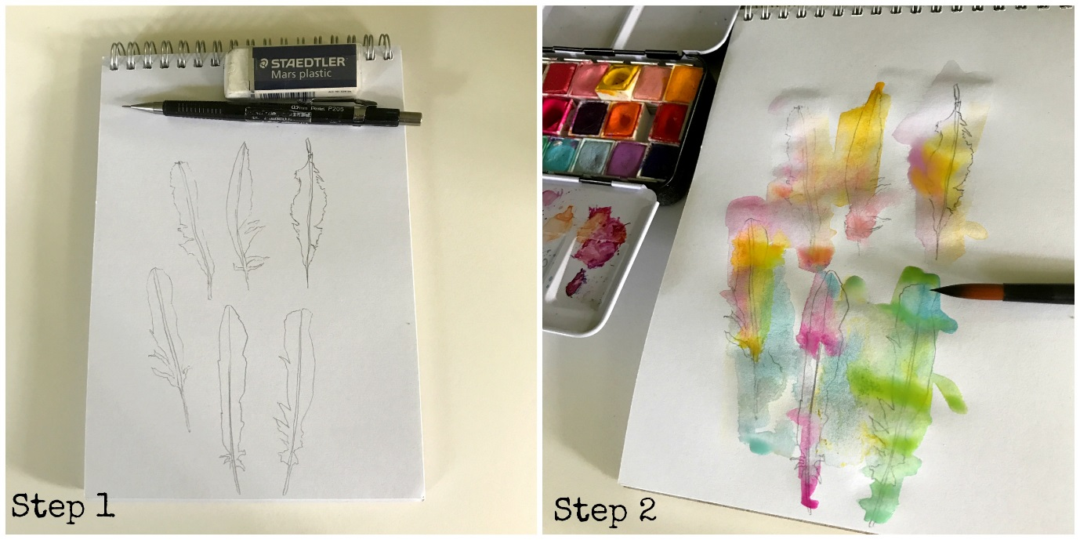

Step 3 & 4
I outline and add definition with water-resistant doodle pens and add scribbles of color with coloring pencils boosting the color vibrancy.

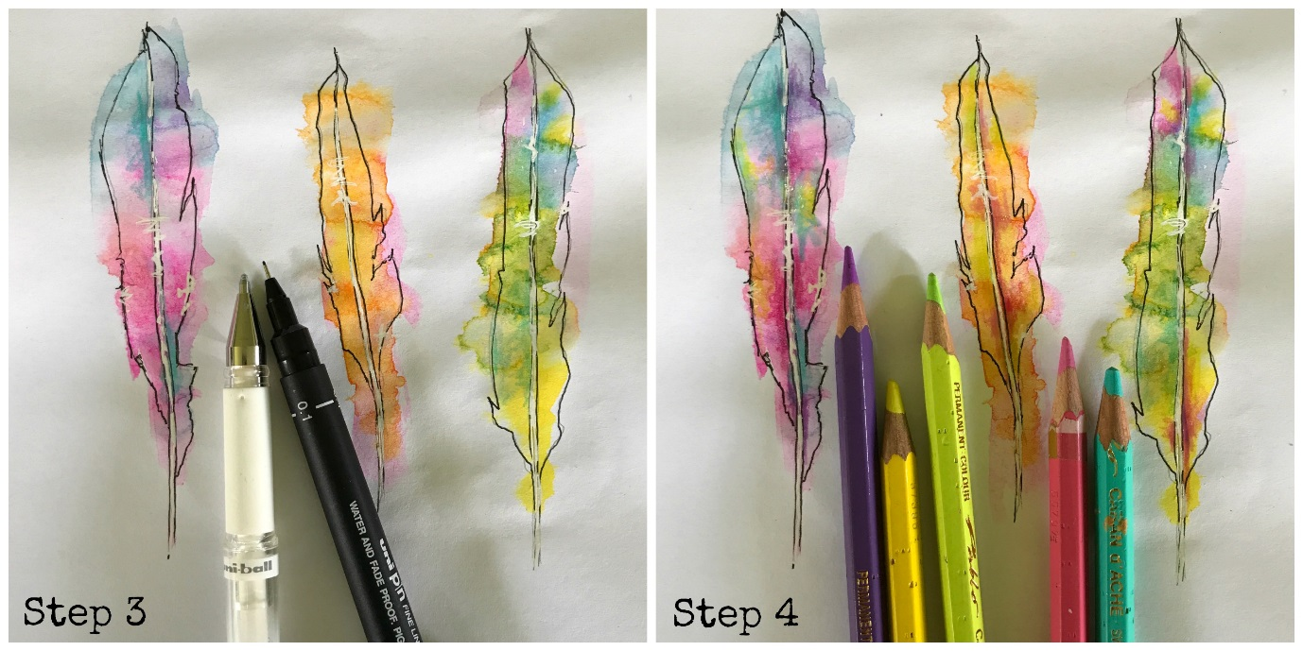

Step 5
I used art Alchemy Impasto Paint to add the patterned stripes of color, with this paint being a thick consistency you can get fabulous texture.
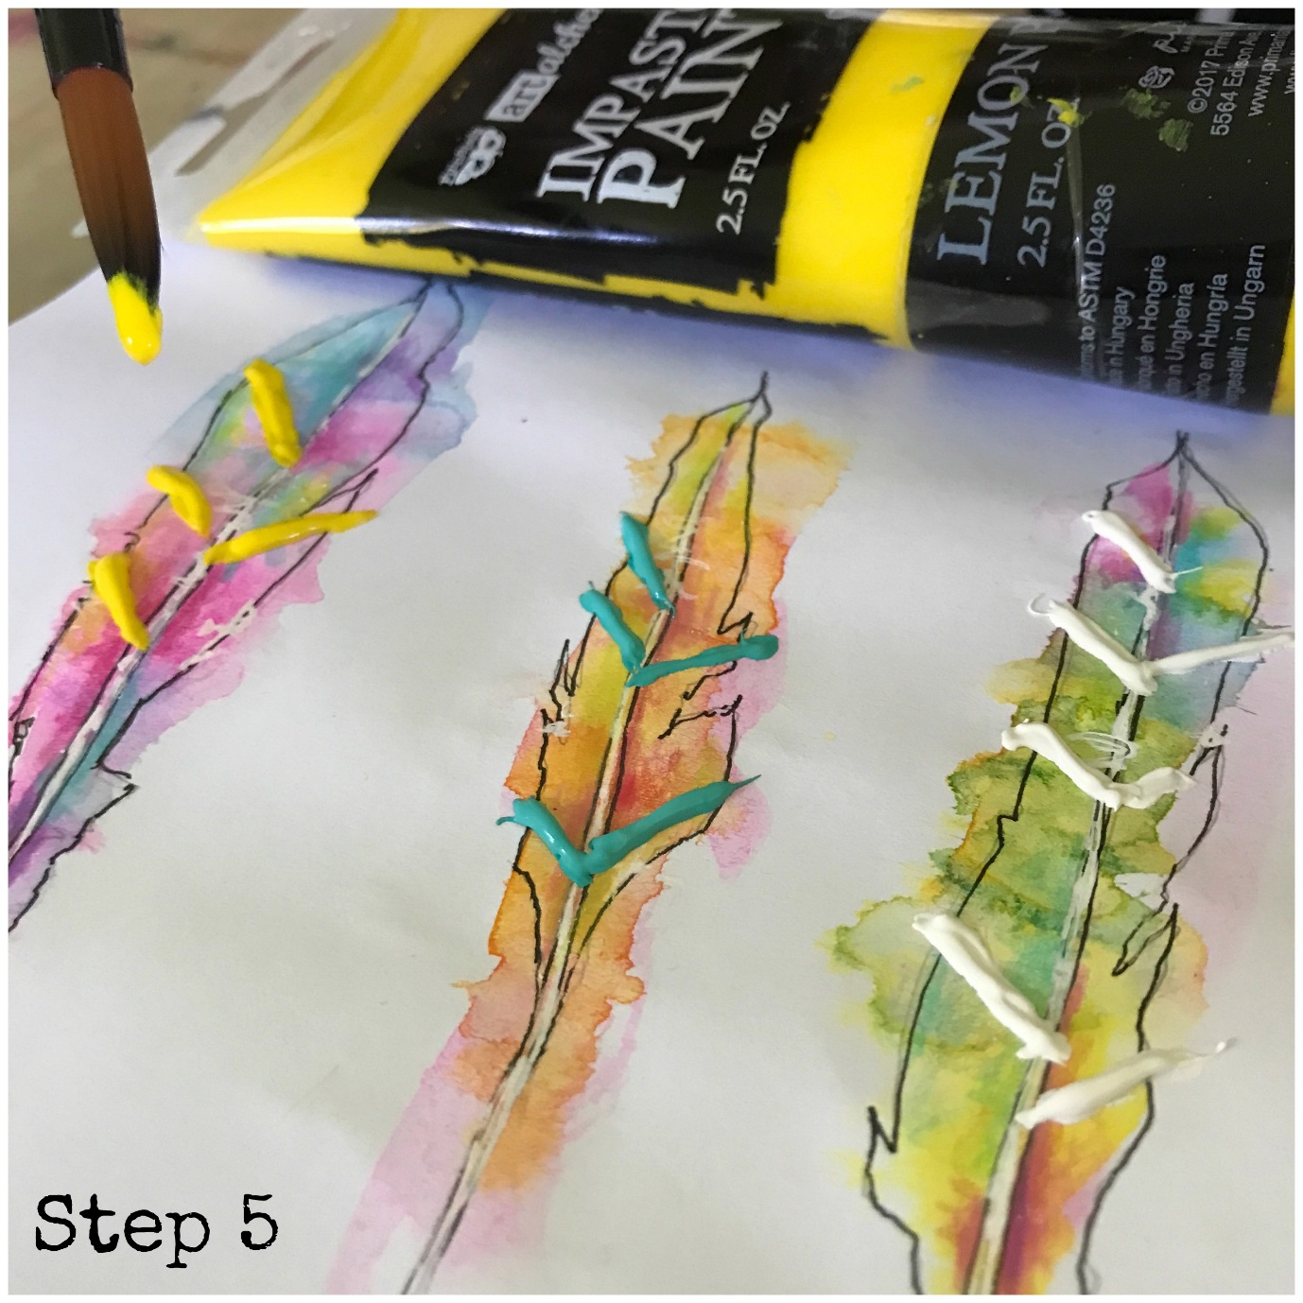
Step 6 & 7
I love creating custom texture paste by mixing Art Ingredients Texture Powder with my favourite acrylic paint and the art Alchemy Sparks paints look uber magical mixed with the powders cos when dry the glitter in the sparks paint twinkles through the texture! The Mini Stencils are amazing for tiny, mini detail and come in so many lush patterns.

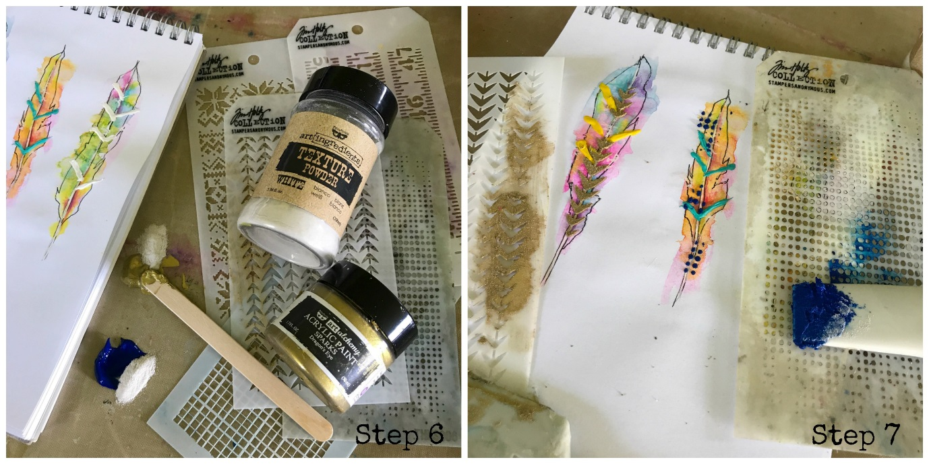

Step 8 & 9
The high shine of the art alchemy Metallique paints look so cool as dots on the feathers, I turn my paintbrush round and use the other end as my tool to apply the dots, and the dotd dry slightly raised too! Finally a few more scribbles and splats with journal pens when all the paint is dry pulls everything together.

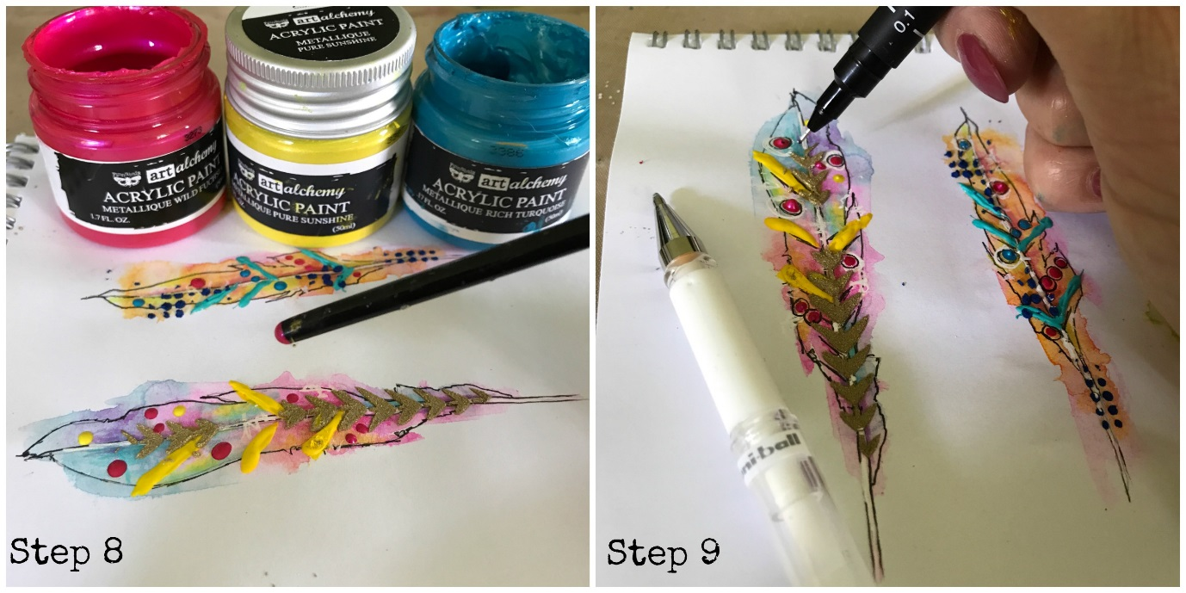

Tip
From step 5 onwards I like to mix up the steps, or simply leave some steps out to mix up the final look of the feathers.

