After 5 incredible challenges highlighting the unique elements from 5 different regions, I am excited to share my project that I created for the Grand Final, focusing on connection and unity among all the regions. My piece Unity includes all 5 of the directions suggested in the brief: circles (representing the globe and the concept of infinity), text referencing the concept of togetherness), the color white (the synthesis of all colors), connection via stitching (symbolizing interlaced unity), and an opening (indicating open mindedness). Here are the steps I took along the way.

1. I painted a piece of cold press watercolor paper with layers of gesso and red, blue and white acrylic paint – a representation of my home the United States of America. Additional design details were added with random stamping of texture stamps from my collection at Impression Obsession. I then tore the paper into two, equal size pieces.

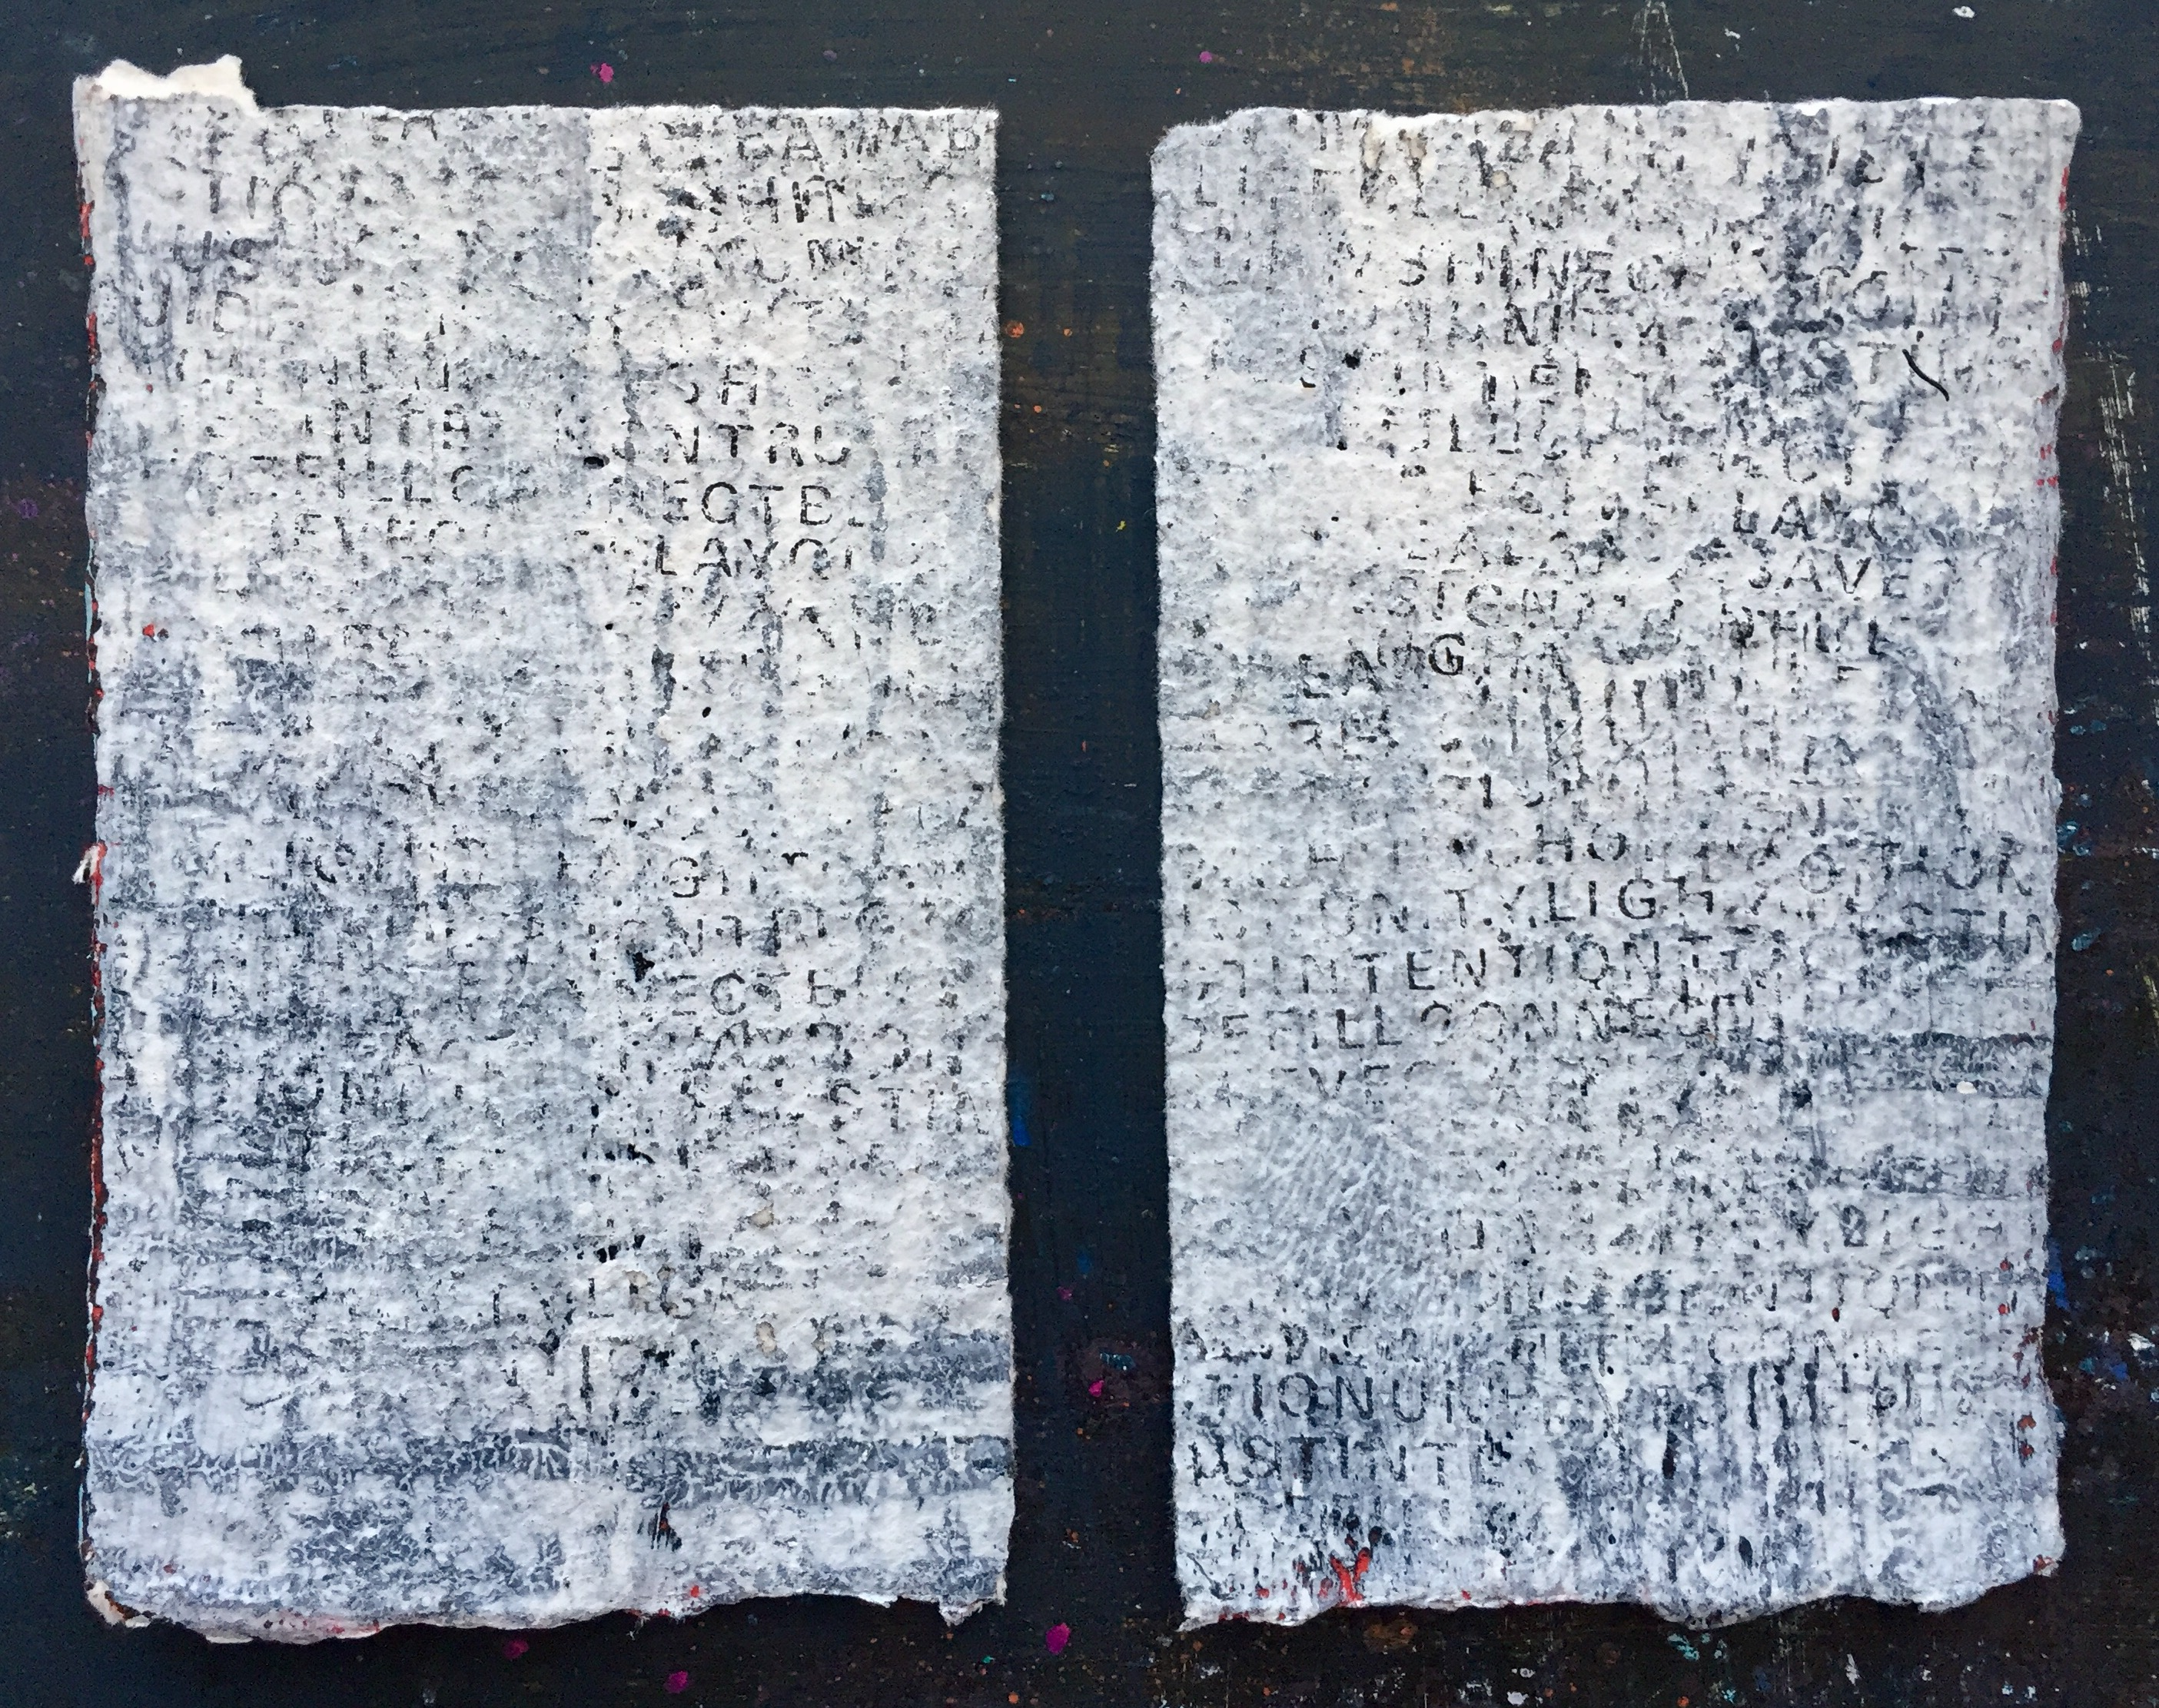
2. Using my Trifecta die cut set from Spellbinders, I die cut a few circular shapes using other sheets of hand painted paper.

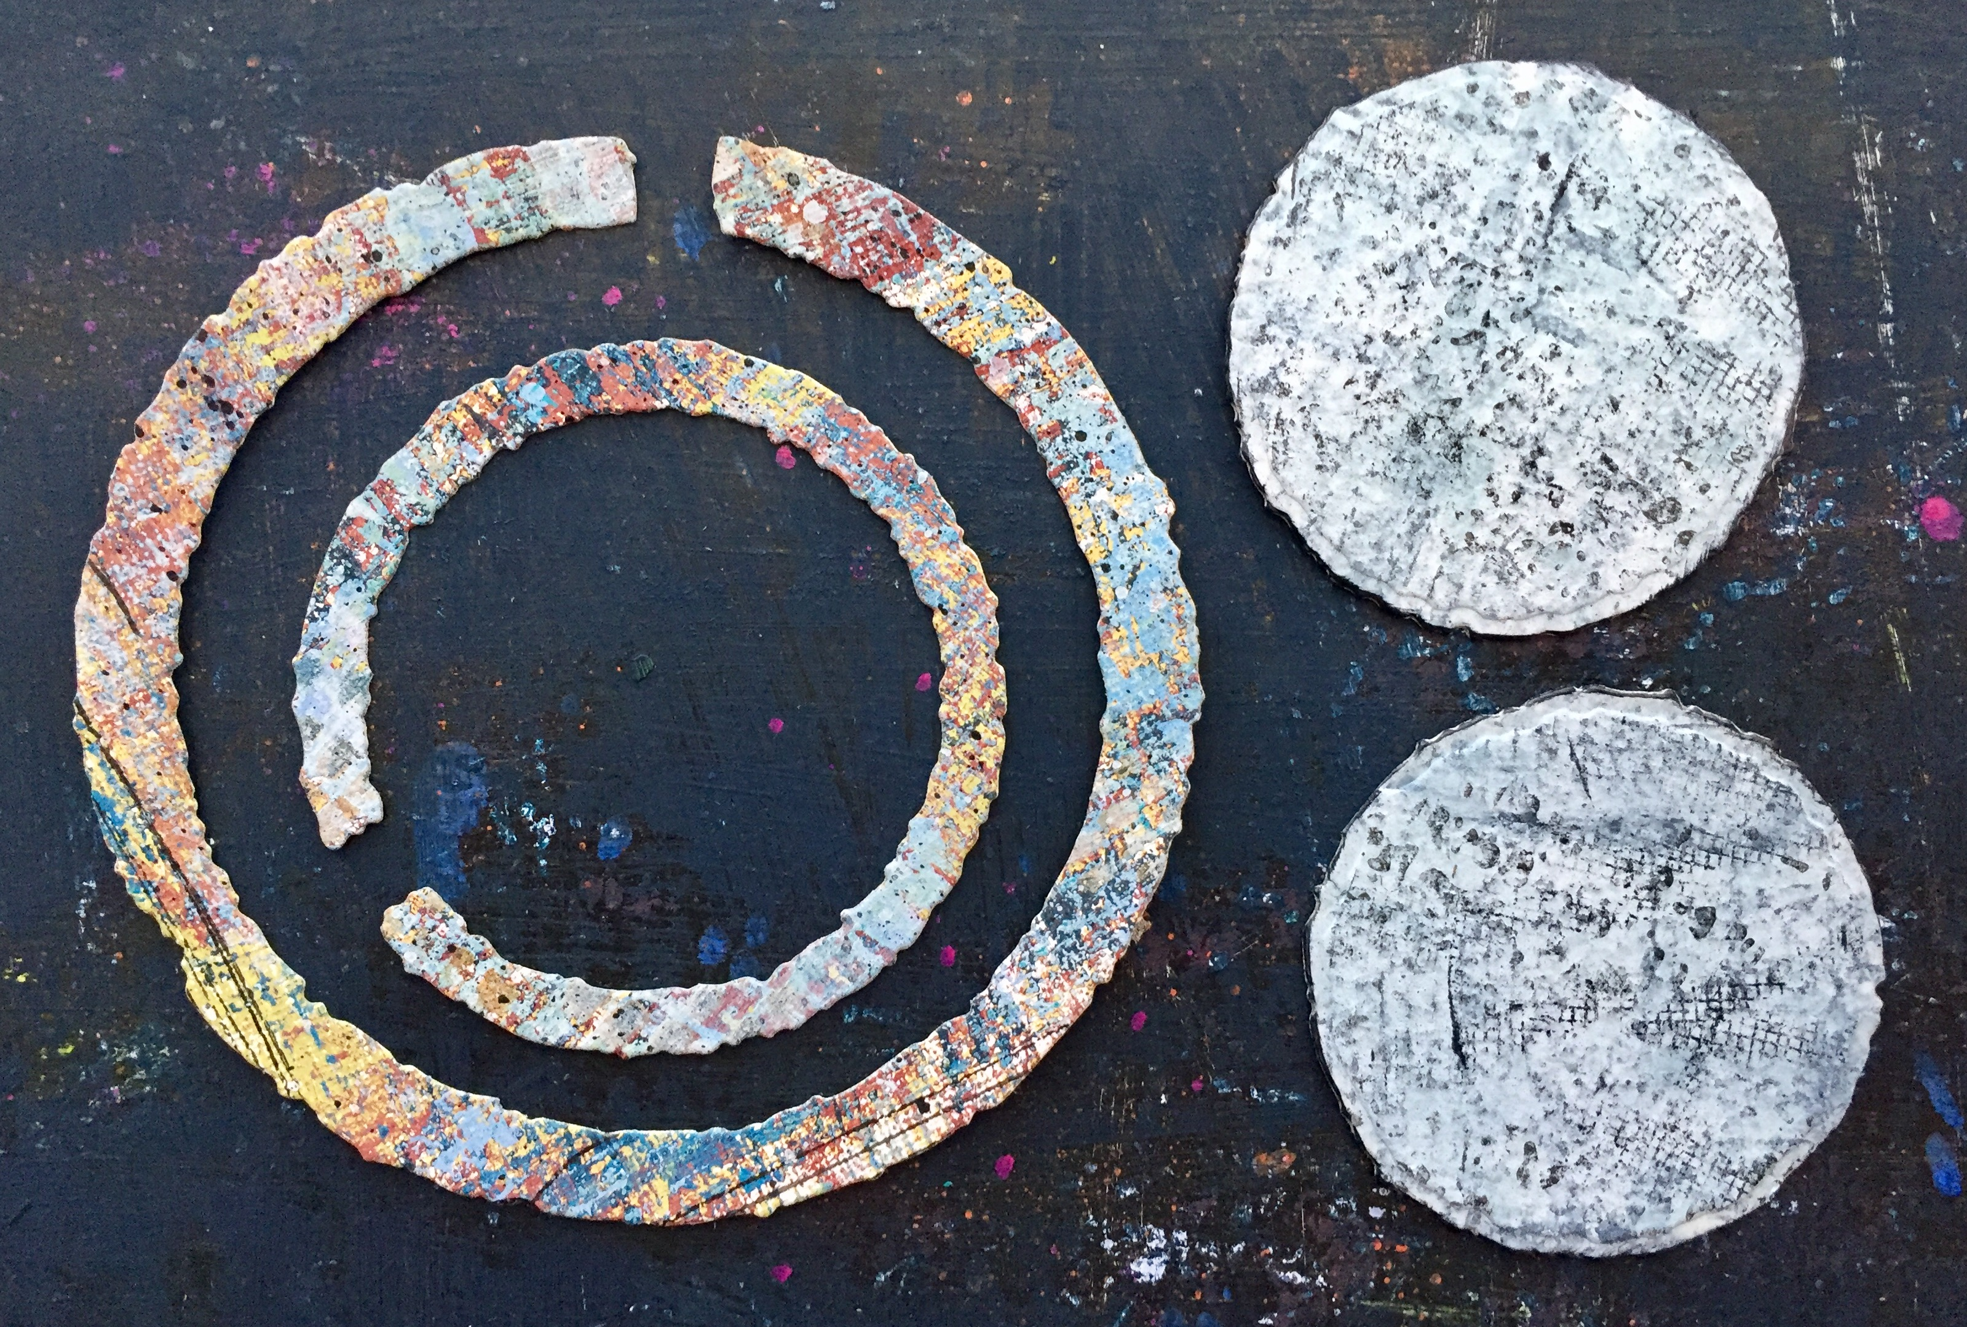
3. I added rub-on text (the words unity, harmony and peace) to paper, trimmed the words, and glued them on to one of the die cut circles. I ran an ink pad around the edge and added pencil marks and splatter for more detail.

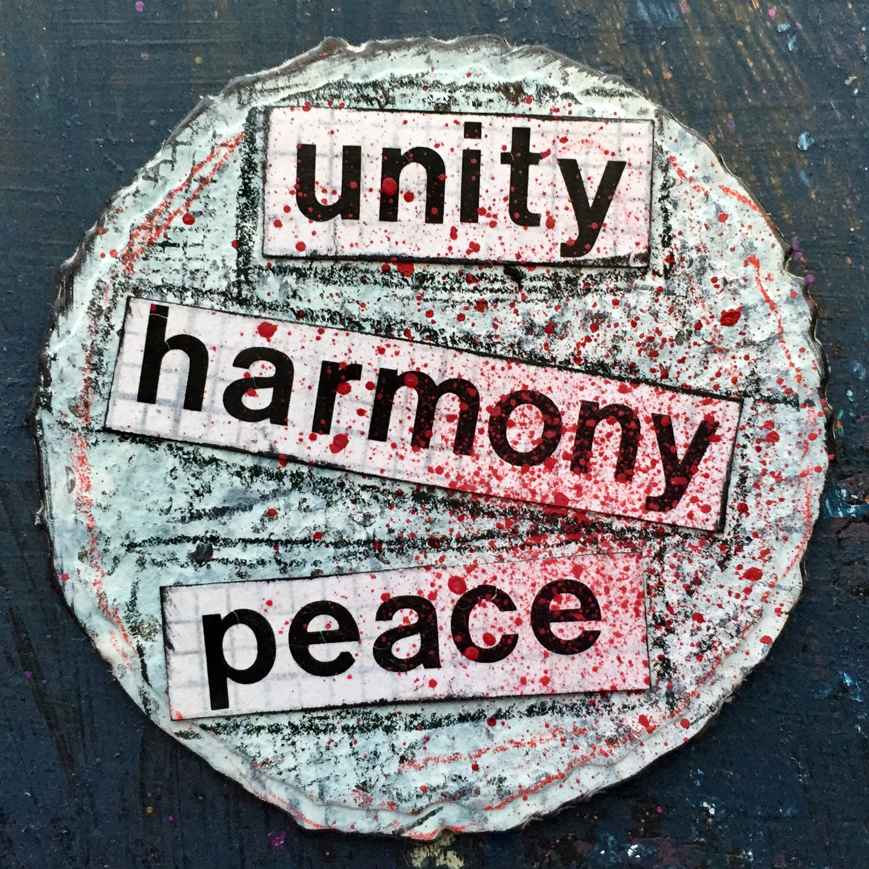
4. I cut and adhered the ring die cuts to my two pieces of painted watercolor paper, added circular stamps from my line at Impression Obsession, and added marks using pencils and a gel pen.

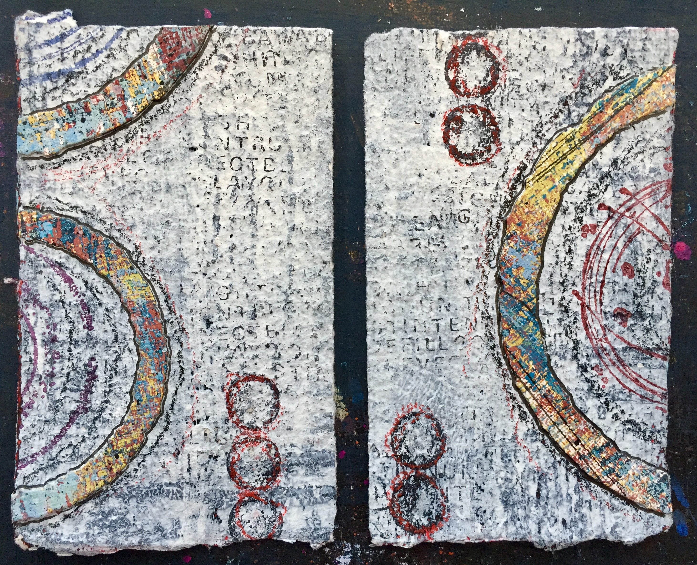
5. Lining up the two pieces of watercolor paper so that there was a gap and making sure that the two pieces did not line up directly, I adhered them together using the circular die cut with the words unity, harmony and peace. All these choices were symbolic of both the tension between and harmony among different regions.

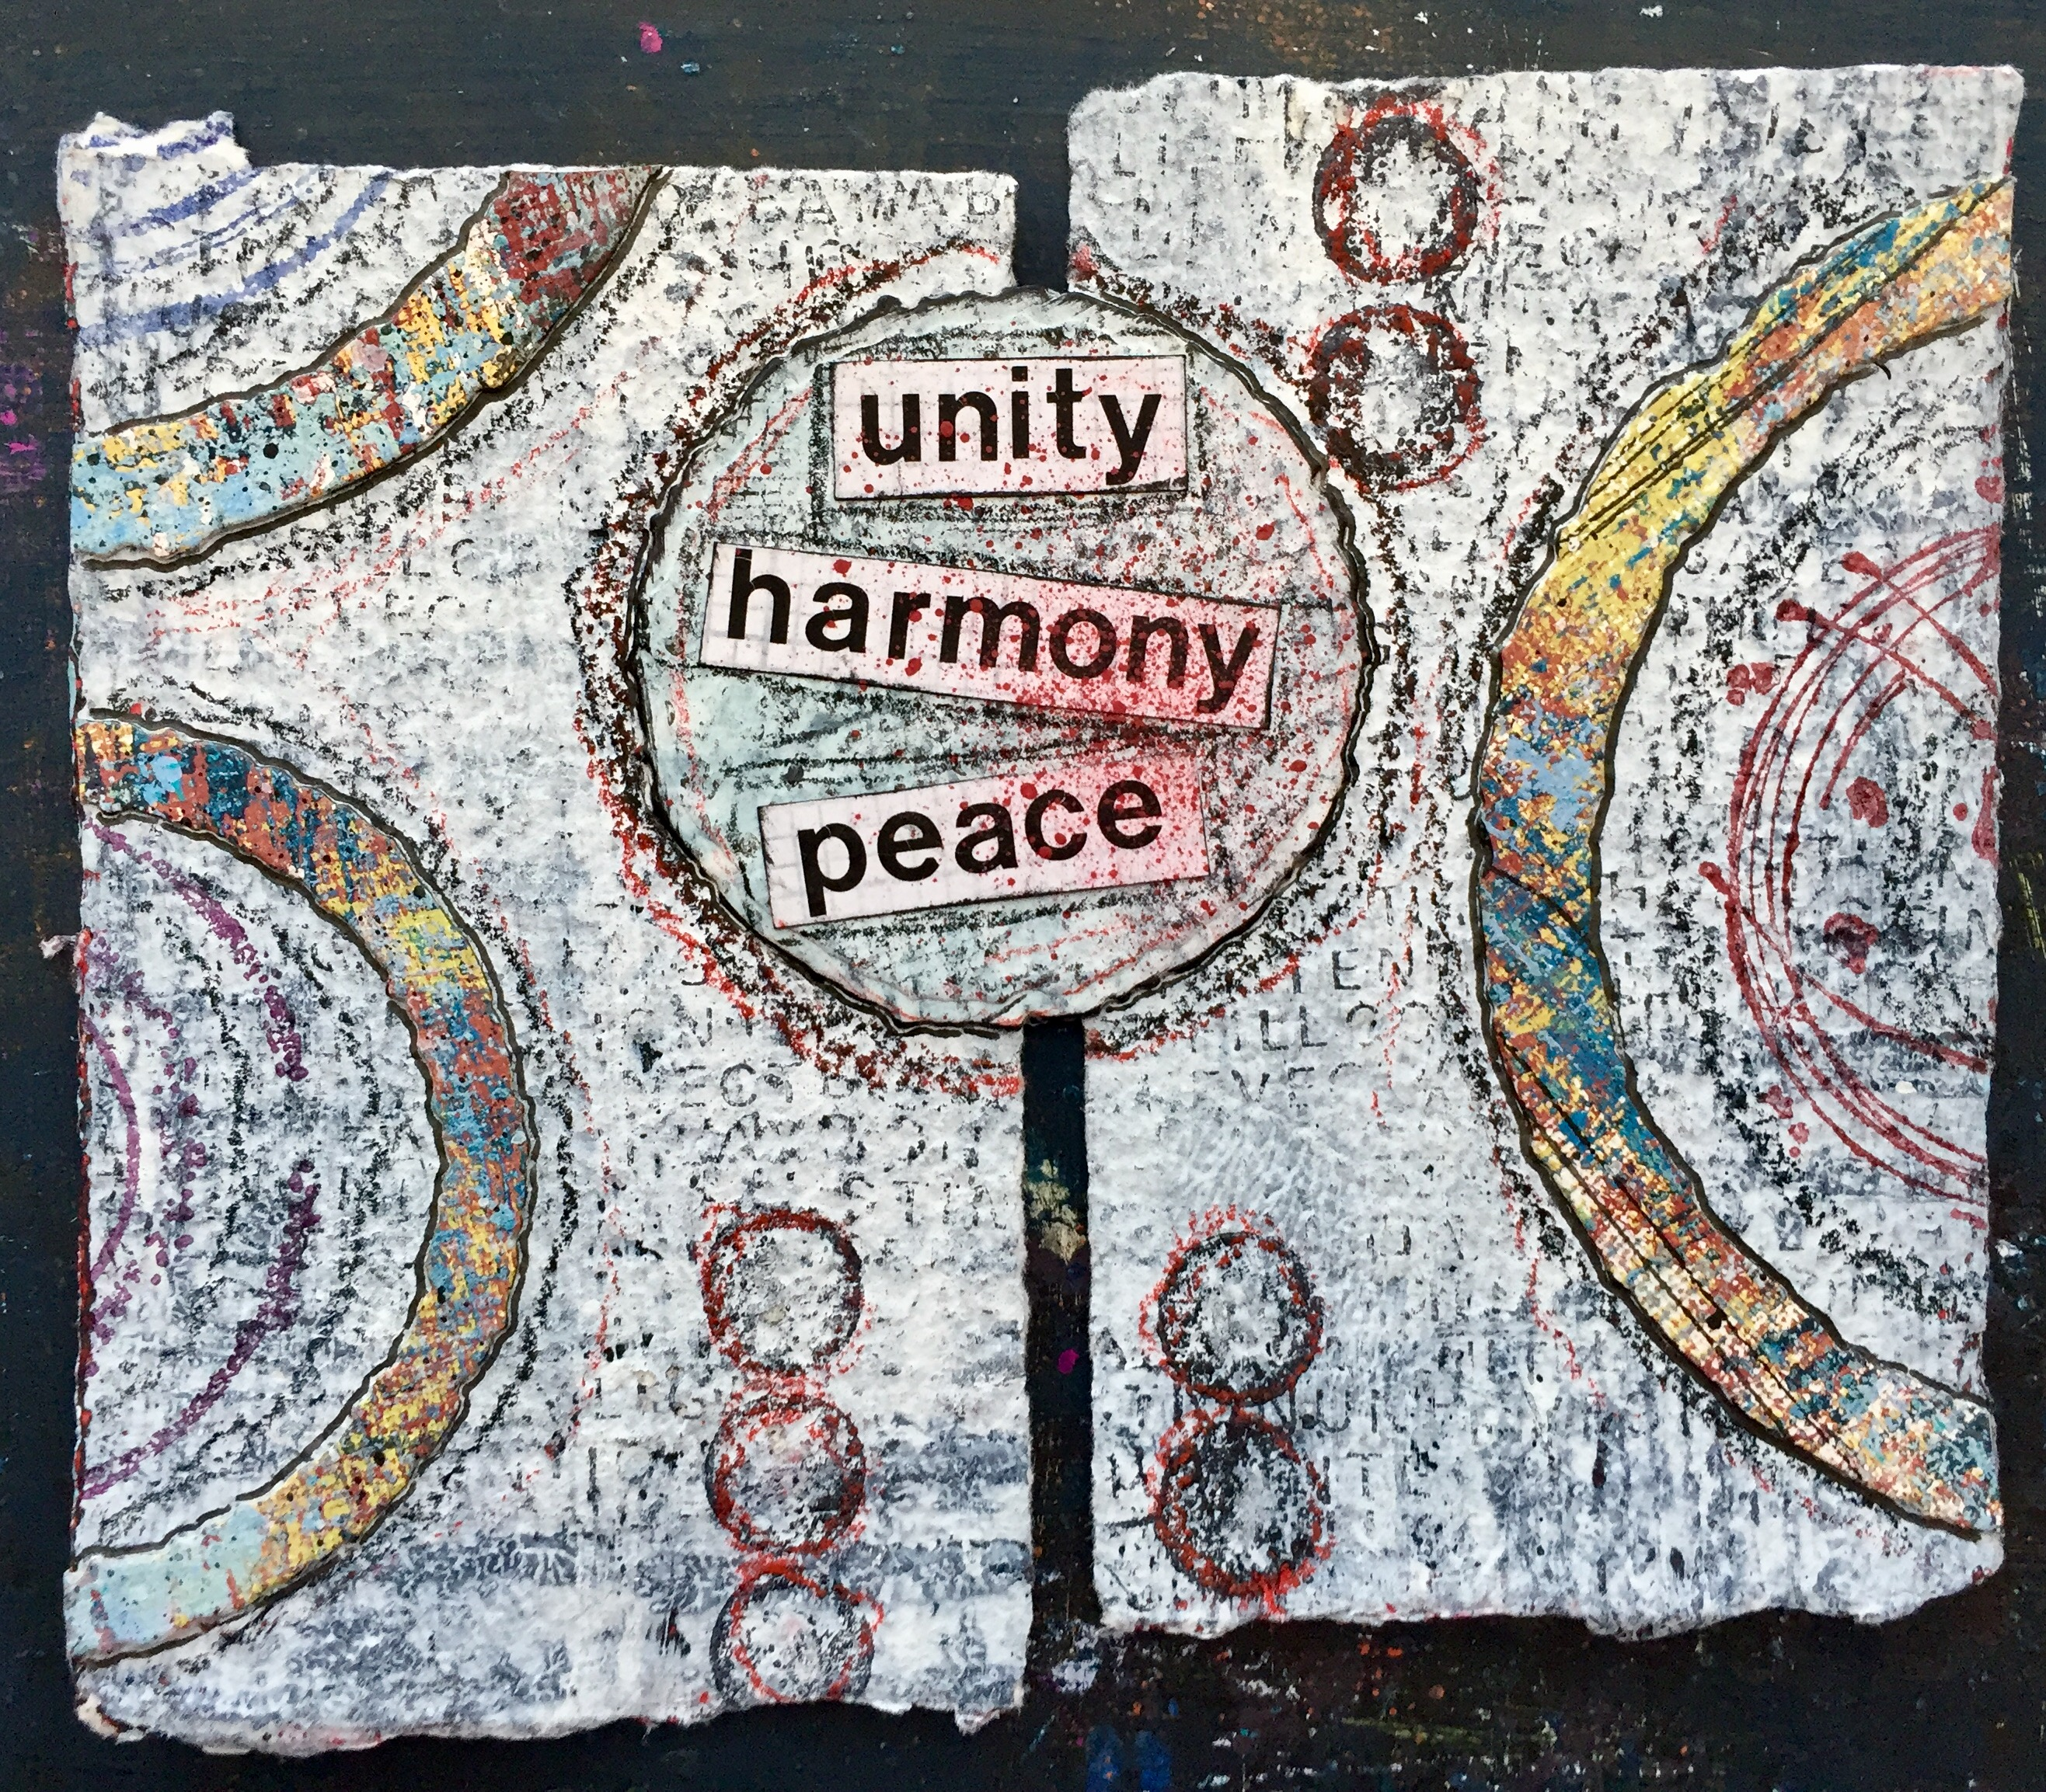

6. As a way to further connect the separate pieces, I stitched together the two sides using waxed linen thread and a needle. Again, also symbolic.

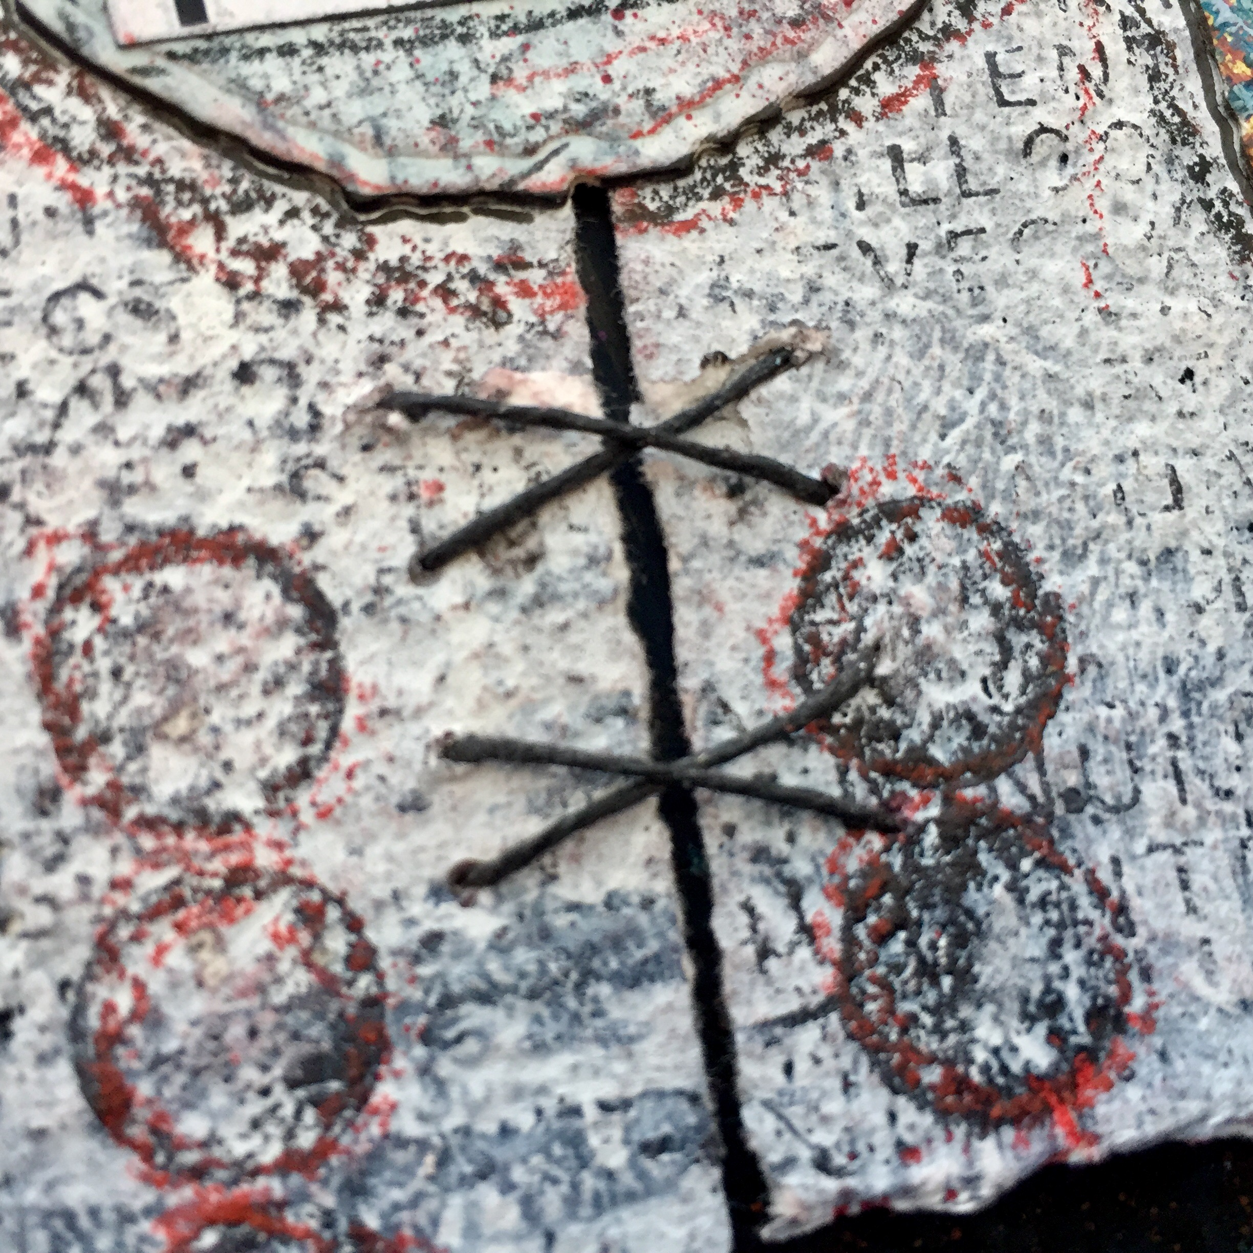
7. As a final touch, I added more handmade marks and paint splatter to unify all the elements.



